ME350

Winter 2025 Semester

DESIGN REPORT #2

Team 35

Wenyue Li

Jiarui Gu

Yang Zhang

GSI/IA: Lawrence Chen

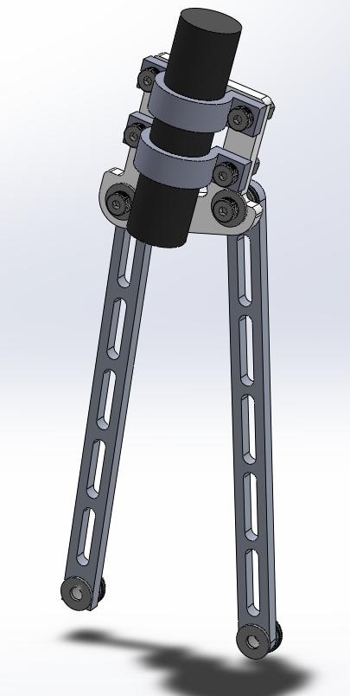

“We have fully abided by the University of Michigan College of Engineering Honor Code”

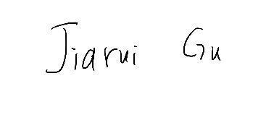  

Audience (Reference Only)

Table & Figure Formatting (Reference Only)

Report Sections (Reference Only)

Due with DR 1 (Sections 1-3, Appendix A):

Section 1: Design Goals, Requirements, and Specifications (0.5-1pg)

Section 2: Design Selection (1-2 pg)

Section 3: Final Linkage Design and Analysis (2-4 pgs)

Appendix A: Assembly Manual

Due with DR2 (Sections 1-8, Appendices A,B, and C):

Section 4: Motion Generator Revision (0.25-0.5 pg):

Section 5: Energy Conversion Introduction (0.25-0.5 pg):

Section 6: Transmission Ratio and Type Determination (1.0 pg):

Section 7: Final Transmission Design (1 pg) :

Section 8: Torque Transfer Analysis (1-1.5 pg):

Appendix A: Assembly Manual

Appendix B: Bill of Materials for the Final Design

Appendix C: Approval Packages

**Introduction**

This project, Plants vs. Zombies, aims to design, build, and test a powered mechanism that can automatically detect targets and accurately shine light on corresponding photosensors to trigger the targets' return. The mechanism must operate efficiently in a dynamic environment, using a DC motor with a closed-loop position control system to precisely position an LED light source. The system’s primary objective is to detect the furthest targets from proximity sensors and activate the photosensors quickly and accurately, ensuring the targets move backward before reaching the front limit switch.

The project is divided into three core modules: Motion Generation, which focuses on the mechanical design for moving the LED to desired positions; Energy Conversion and Transmission, which optimizes the power and efficiency of the system; and Safety and Motor Control, which ensures reliable and secure operation through the use of sensors and control algorithms. The design process emphasizes factors such as mechanical efficiency, target accuracy, power optimization, and system reliability, integrating both engineering principles and practical considerations to achieve optimal performance.

**Section 1: Design Goals, Requirements, and Specifications**

**-Goals**

The goal of this project is to design, build, and test a mechanism that can automatically detect the farthest targets on the playing field using proximity sensors and accurately direct light to the corresponding photosensors to reverse their motion. The mechanism must operate efficiently, using a DC motor in a closed-loop control system to achieve precise and rapid movement of the LED, ensuring timely interaction with the targets before they reach the front limit switch. The design must prioritize accuracy, speed, durability, and reliability to maximize performance across all rounds.

**Requirements and Specifications**

| **Requirement** | **Specification** | **Connection to Project Goals** |
| --- | --- | --- |
| The mechanism must move the LED to the desired positions and orientations with high precision. | Encoder feedback must enable positional accuracy within ±2° of the target. | Ensures precise LED positioning to activate photosensors effectively, achieving the goal of reliable target reversal. |
| The LED beam alignment must not deviate more than ±1.5° from the photosensor's active area. |
| The system must recalibrate to zero position with an error of no more than ±1° after each operational cycle. |
| Transmission Angle should be within an allowable range to prevent undesirable linkage behavior | The transmission angle deviation shall remain within the range of 30° to 150°. | Maintains efficient force transfer for smooth motion, supporting consistent and reliable LED positioning. |
| The average deviation across the mechanism’s range of motion must not exceed 20° from the ideal angle of 90°. |
| Time requirement for speed and responsiveness | The mechanism shall achieve a response time of ≤0.5 seconds per target. | Enables the mechanism to interact with targets quickly, meeting the goal of high performance in time-sensitive rounds. |
| The least operational cycles required for the device | All components shall perform reliably for at least 100 operational cycles under standard conditions. | Ensures the mechanism operates reliably across multiple cycles, meeting the goal of sustained performance. |
| Mechanical components must withstand a maximum static load of 2.5 times the nominal operating force. |
| Maximum weight limitation for the total device and each component | The combined weight of moving components shall not exceed 1.5 kilograms. | Reduces inertia for faster, smoother motion, supporting quick and accurate LED positioning. |
| The flashlight mounting assembly shall weigh no more than 200 grams. |
| The transmission assembly, excluding the motor, shall weigh no more than 1 kilogram. |

**Section 2: Design Selection**

In this section, we adopt a systematic design selection method to systematically select the optimal design among three concepts (Design 1 - Zhang, Design 2 - Li, and Design 3 - Gu) based on both qualitative and quantitative evaluation methods.. This method helps minimize subjective biases, making the decision-making process transparent and traceable. The final design selection not only meets the project’s functional requirements but also excels in manufacturability, cost-effectiveness, and performance.

**Pugh Chart Criteria Selection**

To ensure a comprehensive and rational design selection process, we identified key evaluation criteria based on the project requirements. These criteria consider both technical performance and practical feasibility in terms of manufacturing and usability. The criteria and their corresponding weights are as follows:

*Transmission Angle Deviation - Weight: 4*: Transmission angle deviation directly affects the efficiency and stability of the mechanism’s motion. A smaller deviation contributes to better power transmission efficiency.

*Accuracy of Hitting Target Zones - Weight: 5*: As a core functionality of the system, high accuracy in hitting target zones is crucial for ensuring system effectiveness. This criterion holds the highest weight to reflect its importance.

*Range of Motion - Weight: 3*: A sufficient range of motion ensures the design’s flexibility and adaptability under different operating conditions.

*Power Requirement - Weight: 3*: Power requirements are directly related to the system’s energy efficiency. Lower power consumption helps reduce operational costs and improve sustainability as well as higher reaction speed.

*Friction - Weight: 2*: Lower friction reduces energy loss and enhances the system’s durability and operational efficiency. However, during our design selection, it doesn’t matter so much between different designs

*Part Count - Weight: 1*: A lower part count generally leads to simpler assembly, reduced failure risks, and improved system reliability. Our design focuses on the location and length of input, output and coupler, which is limited to 3 parts.

*Manufacturability - Weight: 3*: Manufacturability determines whether the design can be efficiently produced at scale. Its high weight reflects its importance in the project’s implementation.

*Creativity - Weight: 1*: Creativity encourages unique and innovative solutions. Although it carries a lower weight, it remains an essential factor to promote novel design ideas.

*Price - Weight: 3*: Cost control is critical for the project’s commercial viability. A reasonable cost structure enhances the product’s competitiveness in the market.

**Design Alternatives & Individual design analysis**

This part provides a detailed explanation of the three design alternatives—Design 1 (Zhang), Design 2 (Li), and Design 3 (Gu), which results in the pugh chart. First, *Table 2.1* that summarizes key quantitative metrics derived from individual analyses will also be given to validate the qualitative assessments and justify the final design selection. The key strengths and weaknesses of each design are then analyzed to justify the scores assigned in the chart. Finally, the pugh chart will be given to finalize our selection.

**Table 2.1.** Key Quantitative Metrics for Individual analyses

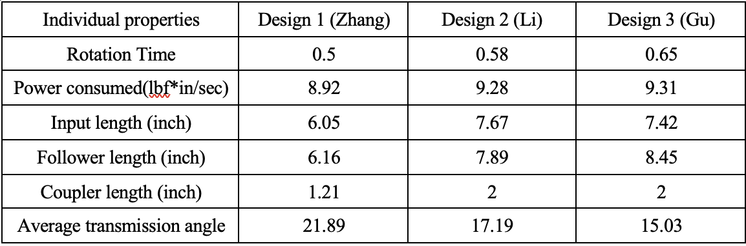

The advantages and disadvantages of each design will be discussed in a brief yet comprehensive format, focusing on key factors such as mechanical performance, energy efficiency, ease of assembly, and potential design limitations. This analysis will provide clear insights into how each design meets the project requirements.

* **Design 1 (Zhang):**
  + *Strength:* Shorter link lengths reduce mass and inertia, leading to lower power requirements and faster operation with the same motor power.
  + *Weakness:* Larger transmission angle reduces mechanical efficiency compared to Designs 2 and 3.
* **Design 2 (Li):**
  + *Strengths:*
    - Smaller transmission angle, leading to better force transmission.
    - Input and follower links are placed on the same side of the coupler, making motor installation and assembly more convenient.
  + *Weakness:* Slightly more complex structure compared to Design 1.
* **Design 3 (Gu):**
  + *Strengths:*
    - The smallest transmission angle provides the smoothest transmission.
  + *Weaknesses:*
    - Collision issue between the flashlight and the mirror when positioned at the far right, reducing the effective target zone and risking damage to the mirror—this is a critical flaw.
    - Although efficient, the design compromises target accuracy due to the limited hitting zone.

Following this, *Table 2.2* presentes the pugh chart to summarize the comparative assessment. The chart integrates both quantitative data and qualitative observations, enabling a structured and objective selection of the most suitable design based on the cumulative performance across all criteria.

**Table 2.2.** Pugh chart for all designs

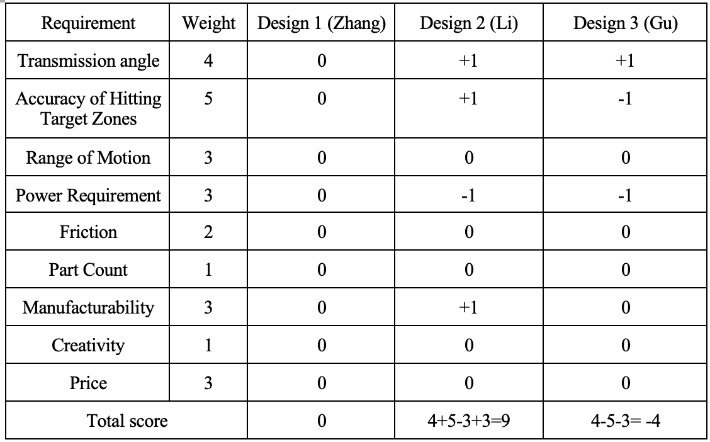

**Discussion of Results and Final Decision**

The Pugh Chart analysis reveals distinct performance trends among the three design concepts. Design 2 (Li) achieved the highest overall score, excelling in key areas such as transmission angle deviation, accuracy of hitting target zones, and ease of assembly. Its balanced performance, with no significant weaknesses, makes it a strong candidate for final selection.

Based on the Pugh Chart results and comprehensive analysis, Design 2 (Li) was selected as the final design. It provides an optimal balance of mechanical efficiency, target accuracy, and ease of assembly, aligning well with the project’s performance and safety requirements. While Design 2 performs strongly, potential areas for improvement include further optimizing power consumption and exploring ways to simplify structural complexity without compromising functionality.

**Section 3: Final Linkage Design and Analysis**

In this section, we introduce the final linkage design we select and do quantitative analysis on this design. We show the assembly on the playing field and give visualization of our design of the linkage as well as hard stops and base plate.

**Final dimension of input, follower and coupler**

The final lengths of our links are shown in Table X below. We set the coupler length at the end of input and follower to be 2 in and the corresponding link lengths are shown. The transmission angle deviation for all linkage positions is shown in *Table 3.1* below.

**Table 3.1.** The length of the input, follower and modeled coupler.

| Input length [in] | Follower length [in] | Coupler length [in] |
| --- | --- | --- |
| 7.67 | 7.89 | 2 |

We test the deviation angle at each of the four targets and get the average deviation angle of four. The measured data is shown in *Table 3.2* below.

**Table 3.2.** The deviation angle of each target and average deviation angle.

| Target 1 | Target 2 | Target 3 | Target 4 | Average |
| --- | --- | --- | --- | --- |
| 15.66° | 4.73° | 7.4° | 40.96° | 17.19° |

As mentioned in the project description, the transmission angle should always lie between 30° and 150° to prevent undesirable linkage behavior. Therefore, the deviation angle should be smaller than 60°. Our design fulfills this requirement as our largest deviation angle is 40.96°.

The locations of the ground pivots are then determined. *Figure 3.1* below shows their location on the playing field.

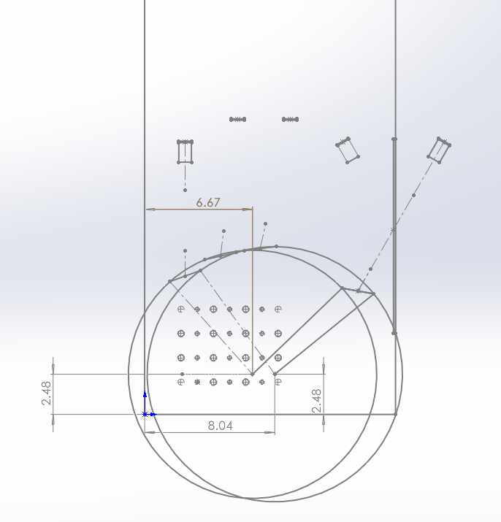

**Figure 3.1.** Shows the relative locations of the ground pivot to the left corner of the setup area.

Specifically, their locations relative to the left corner of the setup area are shown in *Table 3.3* below.

**Table 3.3.** Locations of ground pivots relative to the left corner of the setup area.

|  | x direction [in] | y direction [in] |
| --- | --- | --- |
| Pivot 1 | 6.67 | 2.48 |
| Pivot 2 | 8.04 | 2.48 |

**Joint design**

To ensure smooth rotation between the link and the link and the coupler as well the link and the baseplate, we design a joint structure. *Figure 3.2* below is a sample cross section view of our joint design. Our design uses a needle thrust bearing to facilitate smooth rotational motion between two links (Link 1 and Link 2). The assembly includes a screw, washer, and needle thrust bearing, which are used to secure and support the joint while allowing relative rotation between the links. The needle thrust bearing is specifically designed to handle axial loads while minimizing friction. In addition, the washer between Link 1 and Link 2 are specifically selected to have a smaller thickness, thus ensuring a positive nominal gap.

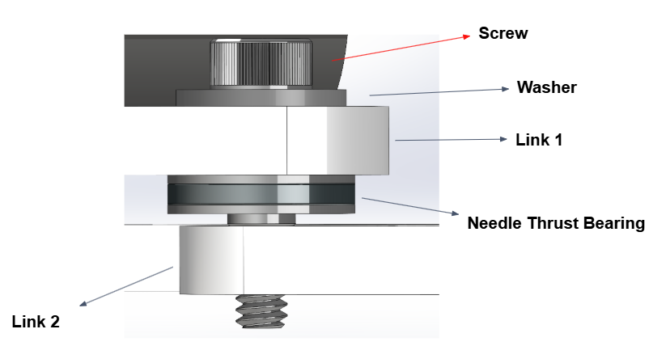

**Figure 3.2.** Cross sectional view of joint design

**Overall assembly on the playing field**

After we determine the design of the link and joints, we create CAD models of them and eventually add them to the playing field assembly. *Figure 3.3* below shows the overview of the assembly, where the flashlight is fixed on the coupler and all the components are fixed to the baseplate.

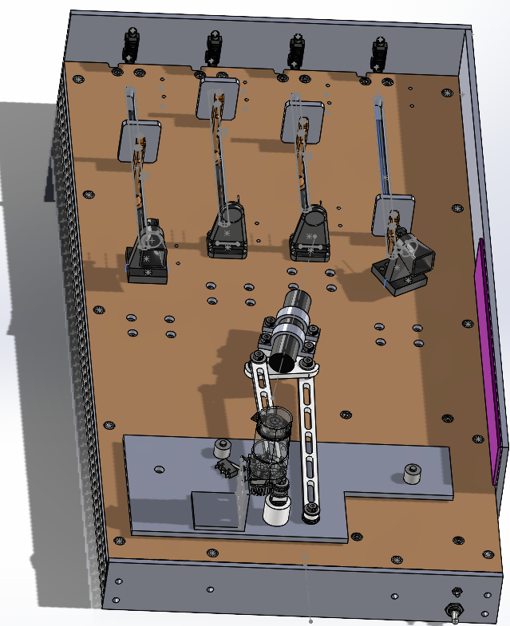

**Figure 3.3.** Shows the overview of the assembly. Input, follower, flashlight, coupler and hard stop are assembled

**Essential components design**

Then we will introduce some essential components in our design.

Hard stops

There are two hard stops on the baseplate. One for the leftmost location and one for the rightmost location. *Figure 3.4* below shows the two conditions when the hard stops act to stop the input and follower.

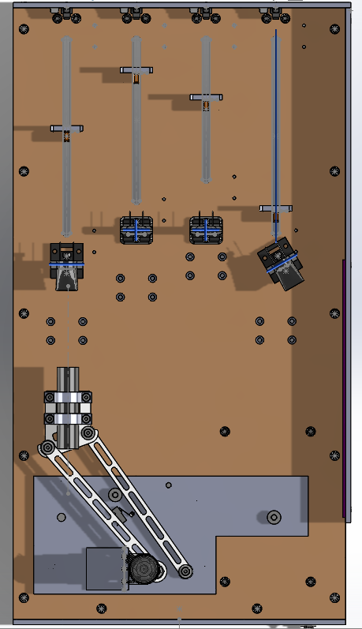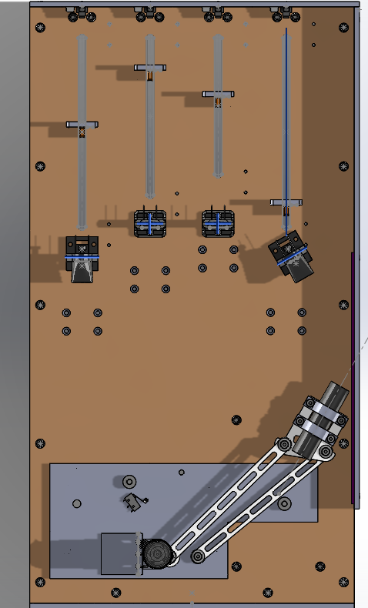

**Figure 3.4.** Shows the leftmost and rightmost condition of the linkage. The two hard stops are used to prevent the link from hitting the wall by hitting the right link.

Flashlight fastener

We use two Ω shaped fasteners to fix the flashlight on the coupler. The inner circle has a diameter of 1 in, which is the same as the provided model of the flashlight. The fasteners are connected with the coupler through screws and nuts. Therefore, vertical forces are exerted on the flashlight to prevent it from sliding back and forth. *Figure 3.5* below illustrates the design of the fastener.

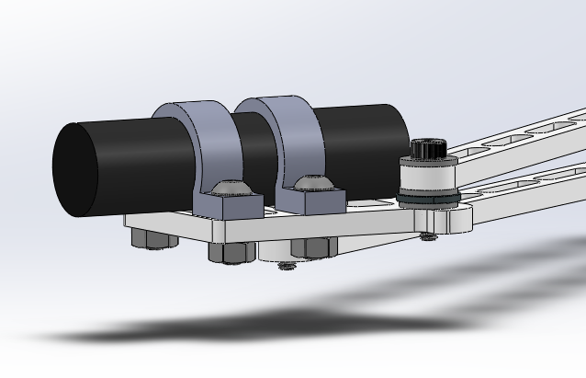

**Figure 3.5.** Shows the flashlight being tightened on the coupler through fasteners.

**Adams analysis**

We put the linkage CAD model into Adams and do the simulation.*Figure 3.6* below shows the CAD model in Adams.

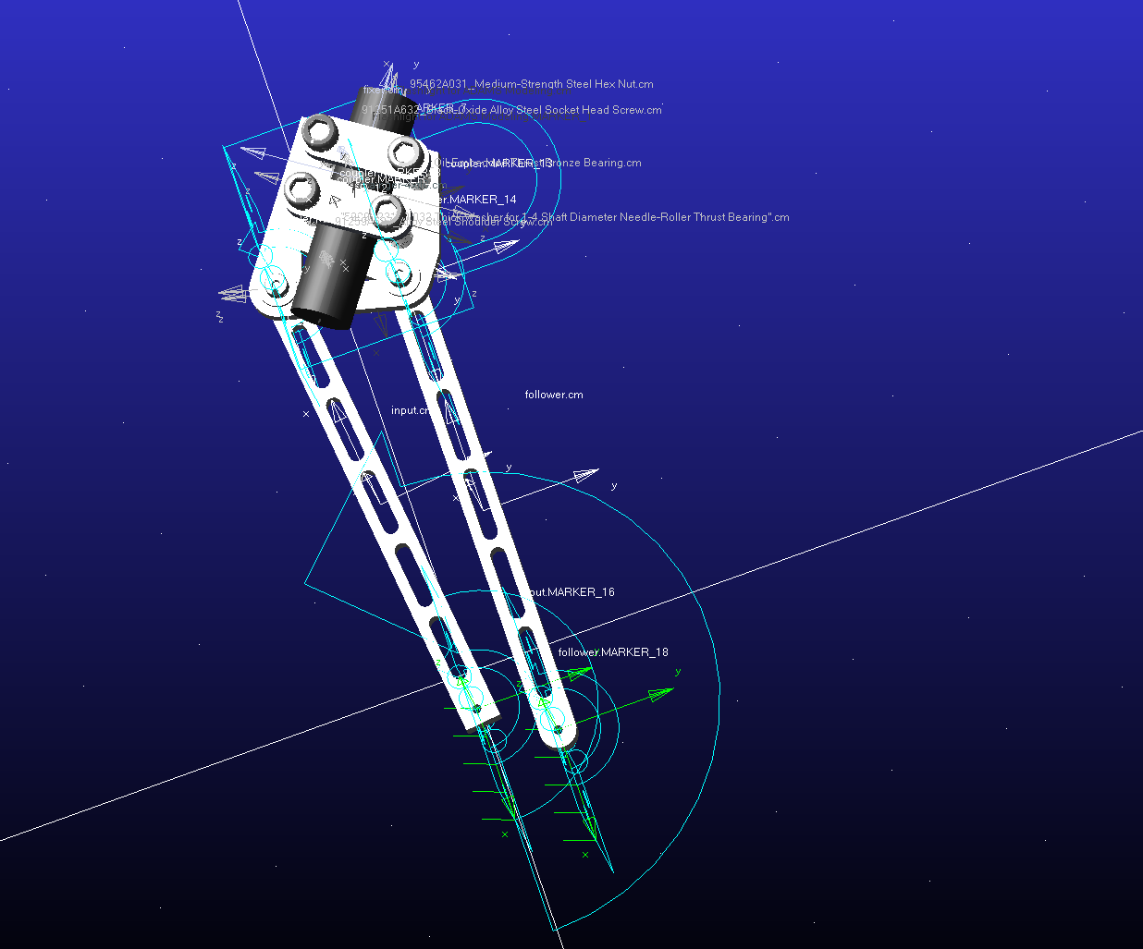

**Figure 3.6.** Linkage CAD model in Adams

After simulation, we get the result of power consumption, angular velocity, angular position and input torque versus time. The results are shown in *Figure 3.7-3.10* below.

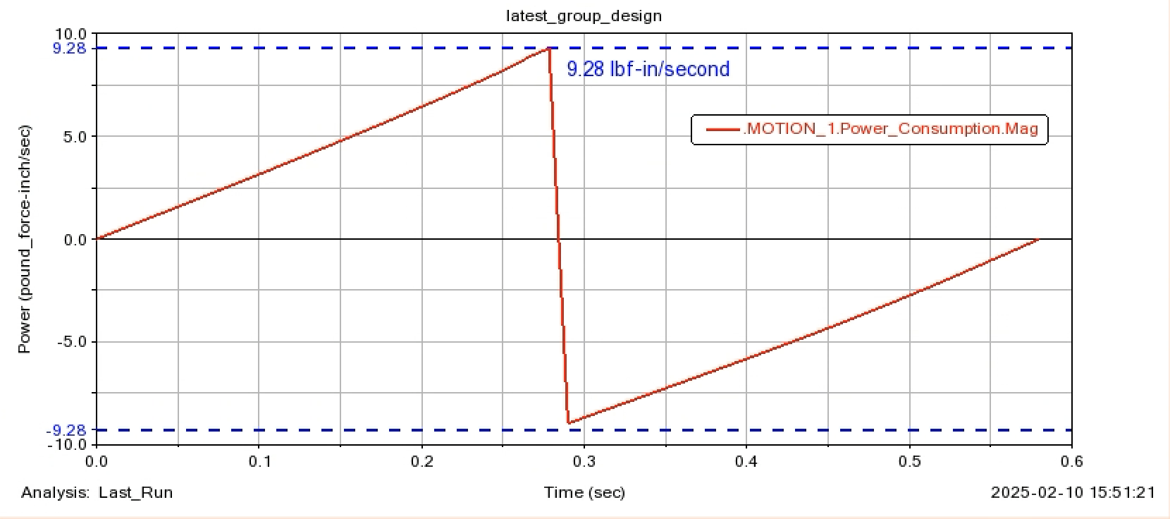

**Figure 3.7.** Power consumption of the linkage vs time

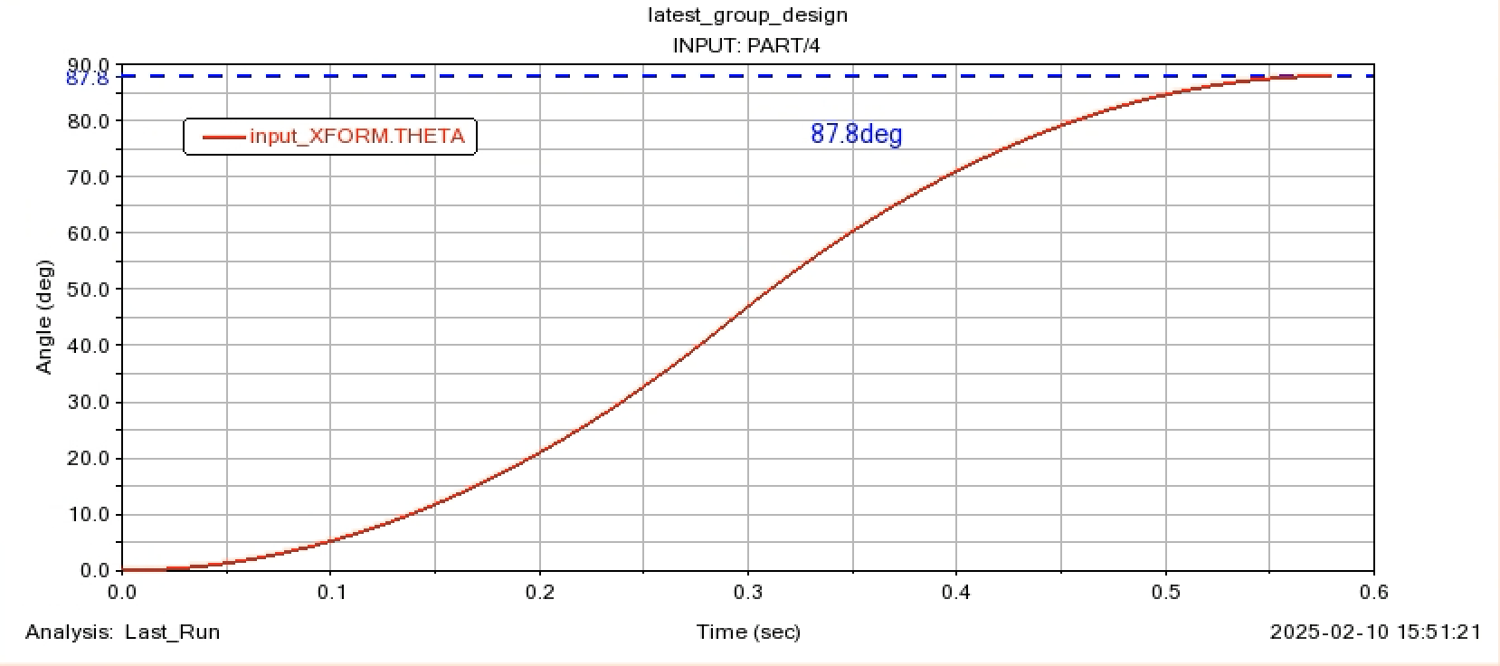

**Figure 3.8.** Angle position of the linkage vs time

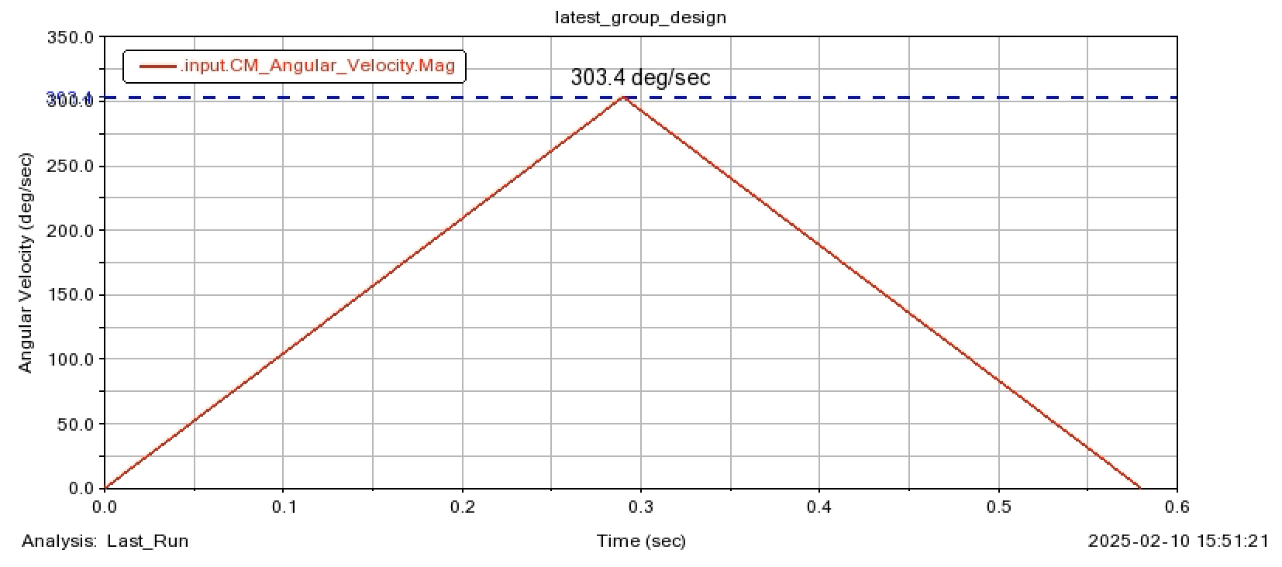

**Figure 3.9.** Angular velocity of the linkage vs time

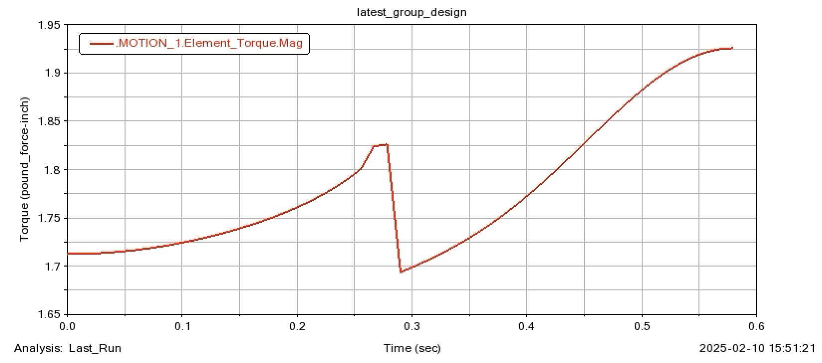

**Figure 3.10.** Input torque of the linkage vs time

From the result we can find that the maximum power consumption is below 1W. Therefore, the result is affordable for the motor to execute. The time it takes from the first target to the final target is about 0.6 seconds. Therefore, we have plenty of room to assign control algorithms to aim at each of the four targets accurately.

**Section 4: Motion Generator Revision**

Since the Gate 1 Review, no changes have been made to the Motion Generator portion of the CAD model. The only changes we make are related to the fixing method, which will not affect the motion generator or its performance. Our original design was validated through initial analysis and testing, meeting all required performance metrics including transmission angle deviation, link lengths, and weight considerations. As a result, no modifications were necessary for this stage of the project.

**Section 5: Energy Conversion Introduction**

A transmission is a device that transfers (mechanical) power from one point to the other. Transmissions can be used to change force, torque, speed, direction, etc. It can provide the necessary torque multiplication to ensure that the machine can operate efficiently. It can also control the speed by changing gear ratios. However, the transmissions will also cause energy loss due to friction between moving parts and thus cause energy loss. They also require extra space and add on the weight. The maintenance costs for complex transmissions are expensive.

In this project, transmissions are composed of gear sets. The transmissions are designed so that the motor can operate the most efficiently. However, gear transmissions require precise alignment between shafts for efficient meshing and they may introduce backlash, which can reduce motion control precision. This requires us to carefully select gears that have the same modules. Moreover, since the moving part of the transmission will add weight to the linkage, weight should be considered when selecting gears.

**Section 6: Transmission Ratio and Type Determination**

**Transmission ratio determination**

In this project, we use two methods to determine the transmission ratio — Inertia Matching and Light beam resolution. The first method can find the transmission ratio that allows the motor to operate most efficiently. The second method can find the transmission ratio that enables the largest count range for the encoder while the light beam falls on the target.

**Inertia Matching**

Since the motor we use outputs constant rotational speed, the steady state speed won’t be affected. The inertia mostly affects the start-up time.

The moment of inertia is given by

$I=I_{m}+\frac{I_{L}}{N^{2}}$

The angular speed and angular acceleration relations are given by

$ω_{m}=N⋅ω_{L}$

$α_{m}=N⋅ω_{L}$

Therefore, we can get the start-up torque of the motor

$T=I⋅α_{m}=(I_{m}+\frac{I_{L}}{N^{2}})⋅{N⋅α}_{L}$

We want to find the transmission ratio that minimizes the motor torque

$\frac{dT}{dN}=I_{m}⋅α_{L}-\frac{I_{L}⋅α_{L}}{N^{2}}=0$

$N=\sqrt{\frac{I_{L}}{I_{m}}}$

Next we need to determine the actual inertia of our load and motor to plug into the equation. The total inertia of the linkage is calculated using the equation shown below:

$I_{total}=I_{input}+(\frac{R_{1}}{R_{2}})^{2}I_{coupler}+(\frac{R_{1}R_{3}}{R_{2}R_{4}})^{2}I_{output}$

Where R1, R2, R3, R4 and R5 are parameters of the linkage. They are shown in Figure 6.1. below.

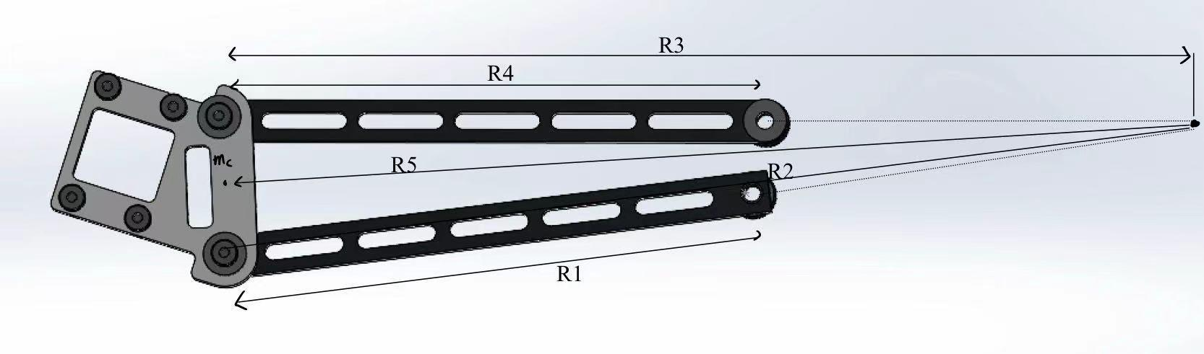

**Figure 6.1.** Shows the parameter lengths of the linkage

Therefore, we can calculate the optimal gear ratio.

$N_{Inertia Matching}=\sqrt{\frac{I_{total}}{I_{motor}}}$

For the project, we take $I_{motor}=25000g⋅cm^{2}$

The result and the parameters are shown in *Table 6.1* below.

**Table 6.1. Parameters and calculated Transmission ratio**

| **Linkage position** | **1** | **2** | **3** | **4** |
| --- | --- | --- | --- | --- |
| **R1[cm]** | 19.493 | 19.493 | 19.493 | 19.493 |
| **R2[cm]** | 46.482 | 56.911 | 63.332 | 45.365 |
| **R3[cm]** | 44.853 | 56.267 | 63.786 | 48.532 |
| **R4[cm]** | 20.038 | 20.038 | 20.038 | 20.038 |
| **R5[cm]** | 47.038 | 58.109 | 65.171 | 48.427 |
| **Total inertia[g*cm^2]** | 27400.46 | 27932.24 | 28393.21 | 30476.98 |
| **Transmission angle [°]** | 74.34 | 85.27 | 82.6 | 49.04 |
| **Transmission ratio** | 1.104 | | | |

**Light beam resolution**

This method enables us to find the transmission ratio that has the largest count range for the encoder while the light beam falls onto the target.

The encoder on our motor has a base resolution of 64 counts per revolution (CPR) on the motor shaft. That means each full revolution (360deg) after the gearbox yields 64*30 = 1920 encoder counts. In other words, we can resolve 360/1920 = 0.1875 deg on the output shaft. We can divide it by the transmission ratio N to get the angular resolution of the input link. We define the desired count range as the number of encoders counts our linkage can move and still have the light beam fall on the target. To get this range, we assume the light beam to be 1 inch wide and the minimum and maximum input link angles are determined when half the sensor is covered by the light beam.

The minimum and maximum angles at the four targets are shown in *Table 6.2* below:

Table 6.2. Minimum and Maximum input link angle at four targets

| **Position** | **Minimum Angle [deg]** | **Maximum angle [deg]** | **Difference** |
| --- | --- | --- | --- |
| 1 | 45.25 | 51.38 | **6.13** |
| 2 | 64.39 | 70.31 | **5.92** |
| 3 | 83.16 | 88.91 | **5.75** |
| 4 | 133.72 | 138.46 | **4.74** |

We then get the desired transmission ratio using Equation below:

$Desired Count Range=(\frac{64 counts}{1 rev})⋅30⋅(\frac{smallest difference [deg]}{\frac{360 degrees}{1 rev}})⋅N$

Taking the smallest difference as 4.74 deg and the Desired Count Range as 30, we get $N=1.19$

The gear ratio we get from the two methods is close to each other. Therefore, we take the larger one for safety and our determined gear ratio is 1.2 for the convenience of selecting gears.

**Transmission type determination**

Common transmission types include gears, belts and chains. Gears are typically made of metal and mesh via teeth to deliver high torque and precision. This makes them ideal for applications requiring exact speed ratios, such as automotive transmissions or industrial machinery. However, they demand precise alignment and require lubrication. Belts are often composed of rubber or reinforced polymers. They run on pulleys and excel in noise reduction and vibration damping. While they tolerate slight misalignment, belts can slip under heavy loads and degrade over time. Chains are constructed from linked metal segments. They can combine durability with high load capacity and can avoid slippage even in harsh conditions (e.g., bicycles, motorcycles). They suit long-distance power transmission but necessitate regular maintenance and lubrication.

We use a Pugh chart to determine the Transmission type for our project. The three potential choices are Gears, Belts, and Chains. We determine our core requirements and assign weight to each item. The chart integrates both quantitative data and qualitative observations, enabling a structured and objective selection of the most suitable design based on cumulative performance across all criteria. The Pugh chart is shown in *Table 6.3* below.

Table 6.3. Pugh chart for Transmission type determination

| Requirement | Weight(%) | Gears | Belts | Chains |
| --- | --- | --- | --- | --- |
| Efficiency | 30 | 9 | 6 | 7 |
| Durability | 25 | 8 | 5 | 7 |
| Cost | 20 | 5 | 7 | 6 |
| Maintenance | 15 | 7 | 6 | 5 |
| Space | 10 | 6 | 8 | 5 |
| Total score |  | 7.4 | 6.2 | 6.4 |

Our final selection of Transmission type is Gears based on the Pugh chart result. The gear attached to the motor is McMaster-Carr 2664N456 with 30 Teeth and 6 mm Shaft. The motor attached to the input is McMaster-Carr 7880K34 with 36 Teeth. Both gears have a 20 degree pressure angle and 0.8 module. They are both made of brass.

**Section 7: Final Transmission Design:**

**Motor & Mounting**

We use brass gears in our design because they reliably transfer the necessary torque without failure during operation. The gear on the motor shaft is securely fixed with a set screw, ensuring a firm and vibration-resistant connection, while the gear on the input link is fastened with a spring pin, which provides uniform load distribution and simplifies assembly.

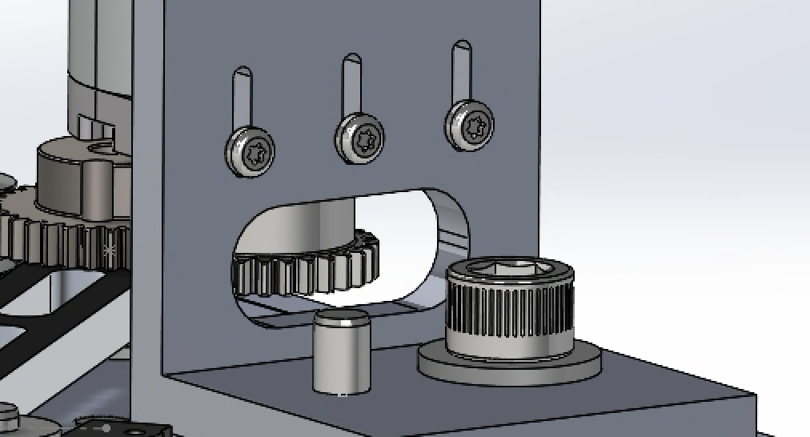 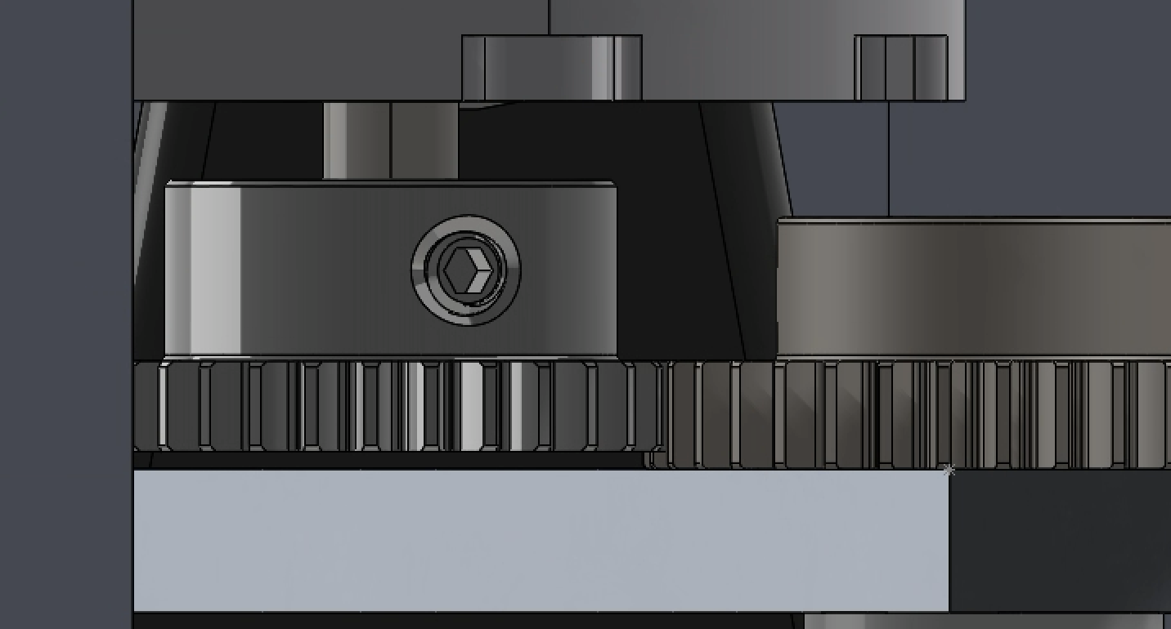

**Figure 7.1 & 7.2** The Motor Fixer

Here we drill a slot hole on the motor fixer, because the radius of the gear on the motor shaft is slightly larger than the distance from the center of the shaft to the surface of the motor fixer. The dowel pin on the motor fixer connects the fixer to the baseplate, and the socket head cap screw is all the way down to the playfield, fixing the location of the fixer to the baseplate and the baseplate to the playfield.

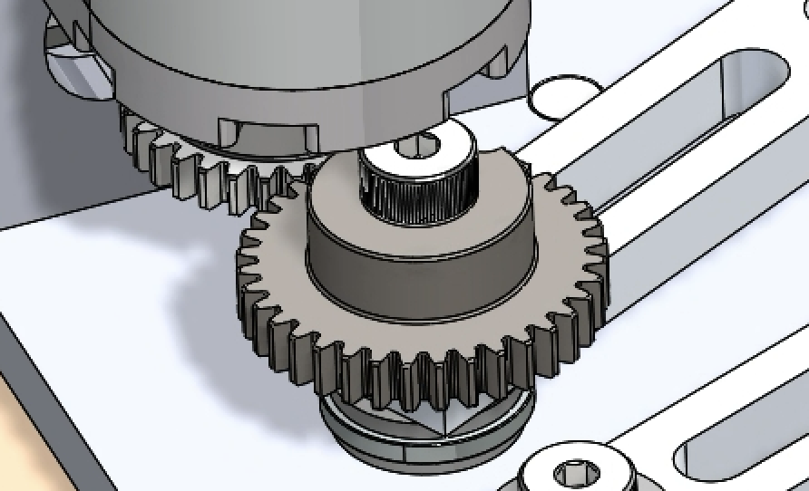

**Figure 7.3** Torque Transferring Joint

**Torque Transferring Joints**

The Torque-transferring joint is the joint shown above. It transfers the torque from the motor to the input link, driving the linkage system to the target position. The gear ratio we choose is 1.2, which means we have larger torque on the input side.

**The Weight of the System**

The original weight of the linkage is 195.219 grams (flashlight: 74.7 grams, input: 37.26 grams, coupler: 45.369 grams, output: 37.89 grams). After we attached the gear to the input link, the total weight of the mechanism increased to 231.439 grams (gear: 36.22 grams).

Here are all the components we used in our design:

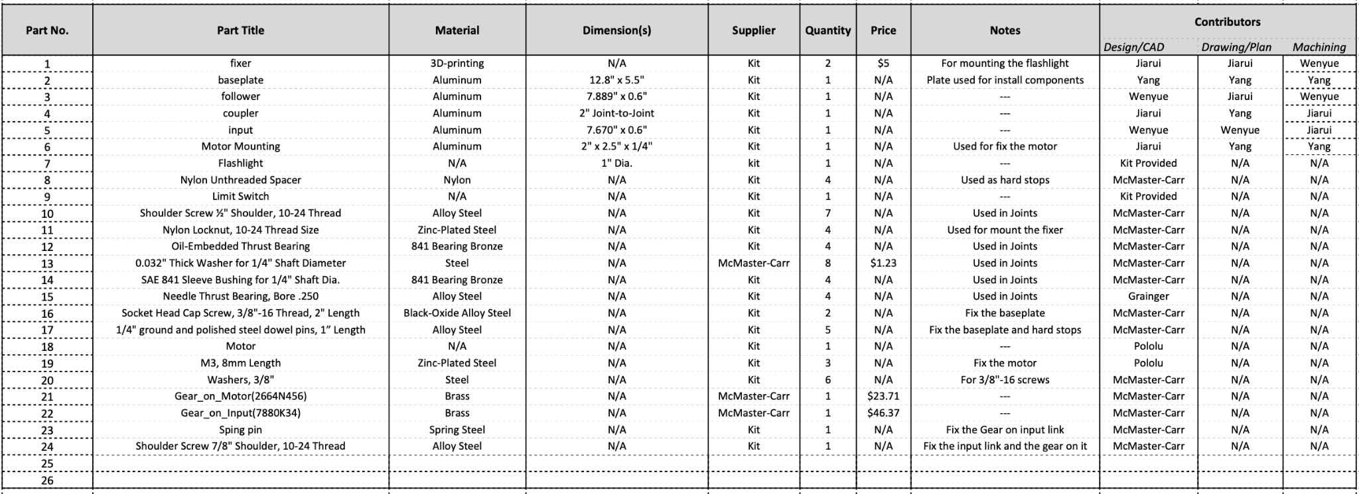

**Table 7.1** Bill of Materials

The following figures show the entire transmission system of our linkage:

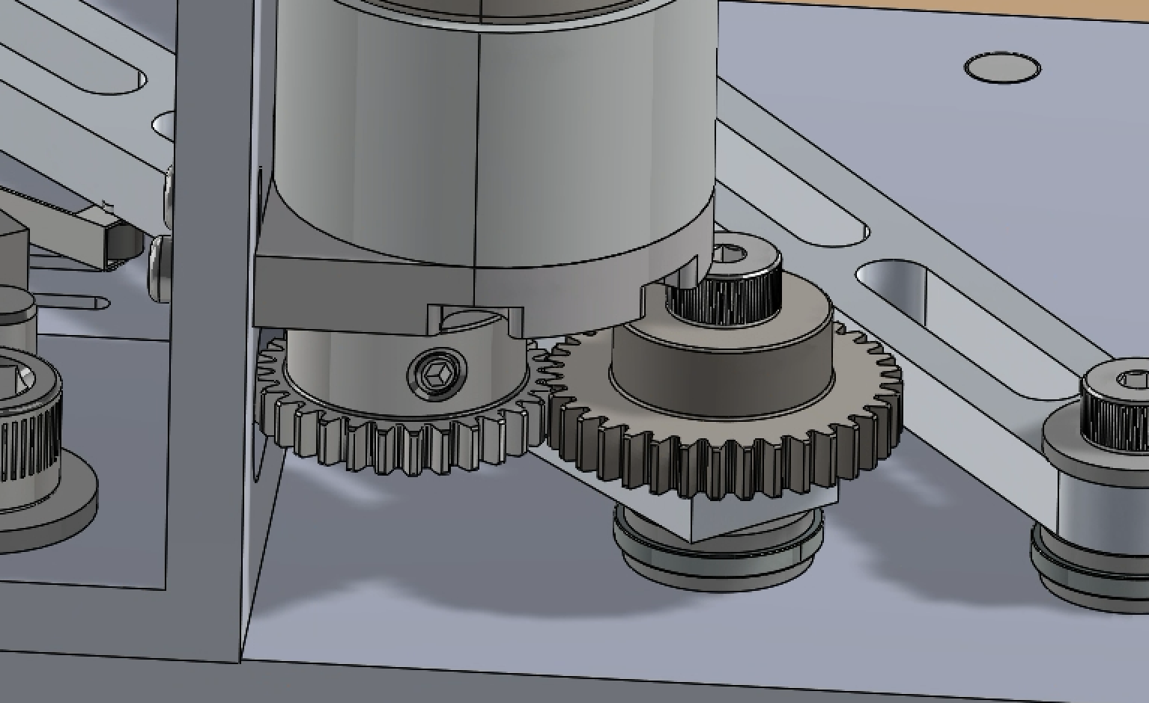 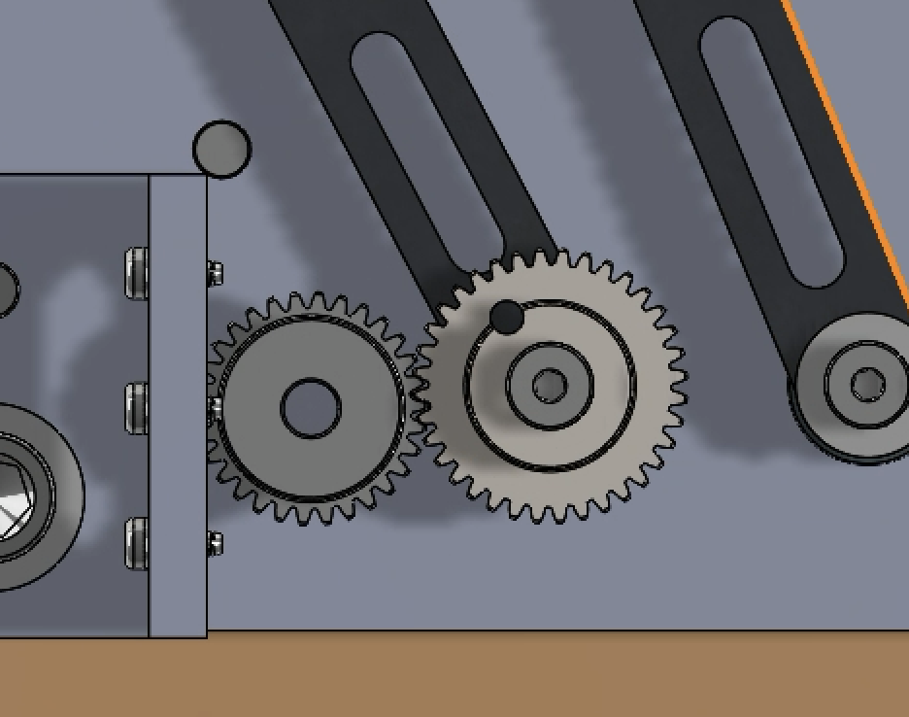

**Figure 7.4 & 7.5** The Transmission System

**Section 8: Torque Transfer Analysis:**

**Introduction**

In this section, a torque transfer analysis is conducted to ensure the reliability and structural integrity of the system’s power transmission components. Two critical joints are analyzed:

1. **Joint 1** – the connection between the motor shaft and Gear 1, which is responsible for transmitting torque from the motor to the transmission.
2. **Joint 2** – the connection between Gear 2 and the input link of the four-bar linkage, responsible for transmitting torque from the transmission to the linkage mechanism.

Torque transfer analysis is performed to confirm that both joints can withstand the applied torque without slippage or failure. This ensures the system operates reliably, avoids energy losses, and maintains the required motion profile.

**Pictures of the Cross-Sectional Views & Freebody Diagram of Both Joints**

The following figure shows the cross-sectional views and free body diagrams of both joints, where the left two images represent joint 1 and the right images correspond to joint 2. These diagrams illustrate the physical connections, and the key forces involved in torque transfer at each point.

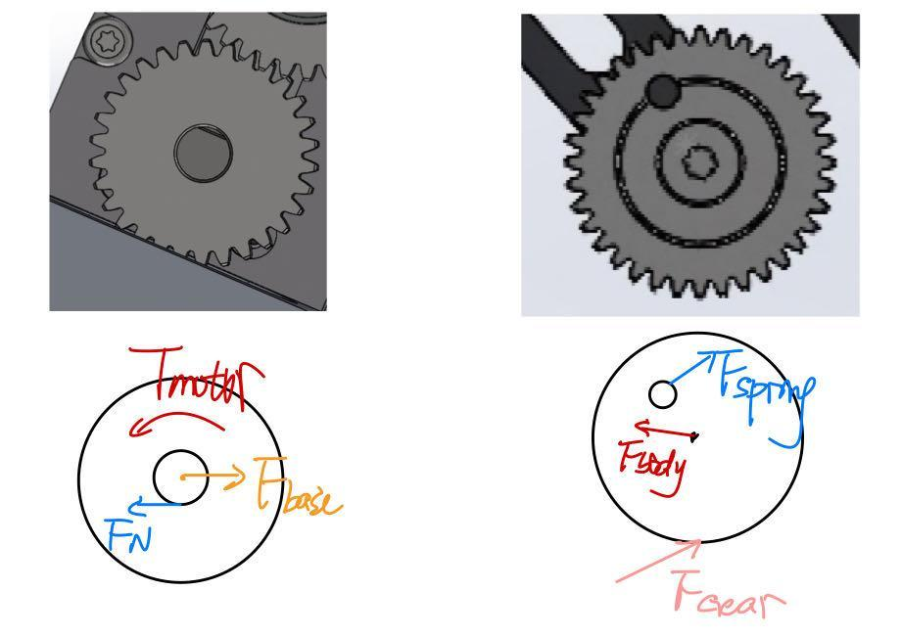

**Joint 1 Analysis: Motor Shaft to Gear 1**

Connection Description

Gear 1 is fixed to the motor shaft using an M4 set screw. The set screw provides a clamping force that enables friction between the shaft and gear hub to transmit torque.

Calculation Process

The transmittable torque by the friction force is:

$T = μ × F_{N}×r=0.51 × 1712 ×0.003 = 2.62 N⋅m$

Where $μ = 0.51$ is the friction coefficient, $F_{N}=385 lbf = 1712N$ is the preload applied by M4 set screw at standard torque, $r = 3mm$ is the shaft radius.

Assumptions

* Proper tightening of the M4 set screw is achieved, ensuring the full normal force.
* The coefficient of friction is stable, and no surface contamination reduces it.
* Only one set screw is used. If there were two present, torque capacity would double.

Failure Evaluation

* The motor outputs a **maximum torque** of **1.37 N·m**.
* The set screw connection can withstand 2.62 N·m, which is sufficient.
* The torque capacity is more than the motor's stall torque, no risking slippage under high loads. The safety factor $SF = 2.62/1.37 = 1.91$, which reflects the safety of Joint 1.

Material Comparison

The material of Gear 1 is brass, and the set screw is steel, with sufficient material strength to support the normal force without material deformation.

**Joint 2 Analysis: Gear 2 to Input Link (Spring Pin + Screw Connection)**

Connection Description

Gear 2 is connected to the input link through a spring pin and a central screw. Torque is transferred by the shear resistance of the spring pin. The maximum torque transmitted from the motor to Gear 2 is 1.37 N·m. The spring pin has a diameter of 0.1425 inches (3.62 mm), and the distance from the center of rotation to the center of the pin is 0.3495 inches (8.88 mm).

Calculation Process

Torque is transmitted by double shear through the spring pin.

$τ = \frac{F_{Gear } × r_{Gear }}{d_{pin-center} × A}= \frac{T_{in}}{d_{pin-center} × π × {d_{spring}}^{2}/4 } =\frac{1.37}{0.0088773 × π × 0.0036195^{2}/4}=14.99MPa$

Where $T_{in} = 1.37N⋅m$ is the maximum torque transferred by the motor, $d_{pin-center} = 0.3495in = 8.8773 mm$ is the distance from the screw center to pin center $d_{spring} =0.1425 in =3.6195 mm$ is the diameter of the spring pin.

Assumptions

* Load is evenly distributed.
* No impact or dynamic overload is considered.

Failure evaluation

The calculated shear stress (14.99 MPa) is much lower than the shear strength of the pin material (about 250 MPa), and the connection is safe.

**Gear-to-Gear Torque Transfer Analysis (Lewis Bending Stress Analysis)**

A Lewis bending stress analysis was performed to evaluate the gear tooth strength during torque transfer between Gear 1 and Gear 2.

Lewis Equation

$σ = \frac{K_{v}⋅W^{t}}{F ⋅ m ⋅ Y} = \frac{K_{v}⋅2T/d}{F⋅m⋅Y}= \frac{1.1 × 2 × 1.37/0.024}{4 × 0.8 × 0.3}=130MPa$

Where $m = 0.8mm$ is module, $K_{v} = 1.1$ is velocity factor, $W^{t} = 2T/d$ is the transmitted load, $F = 4mm$ is module, $Y=0.3$ is the Lewis form factor for 30 teeth and $20^{∘}$ pressure angle.

Conclusion

The bending stress on the gear tooth is 130 MPa, which is below the material’s yield strength (~250 MPa). This indicates the gear is structurally adequate under maximum torque loads.

**Appendix**

**Step 1:** Install the sleeve bearings on both sides, ensuring they fit snugly around the shaft. Check for smooth rotation after installation.

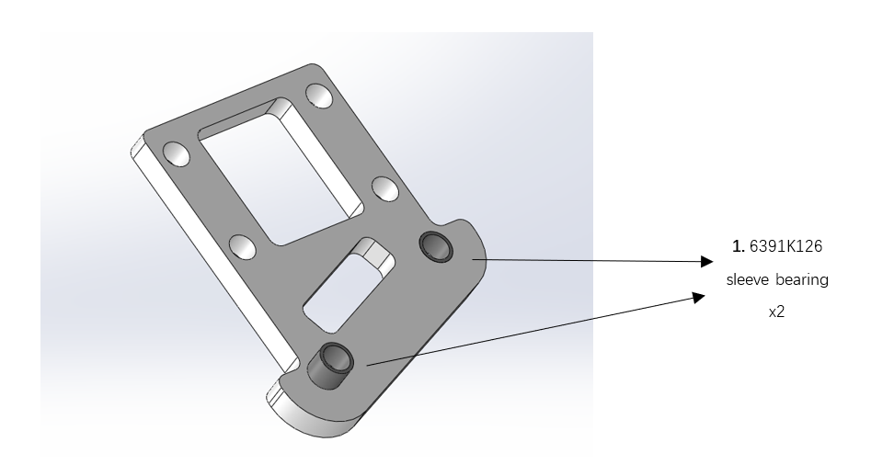

**Step 2:** Attach the fixer and coupler to the base plate using two shoulder screws and nylon lock nuts. Ensure the screws are aligned with the holes for a secure fit.

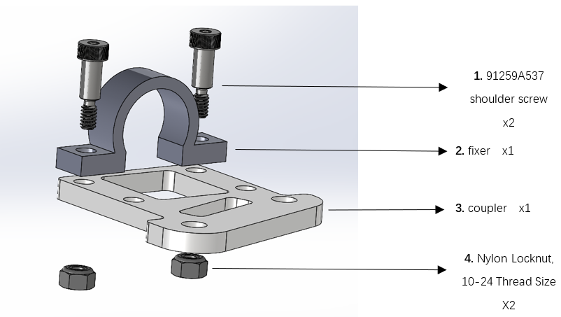

**Step 3:** Insert the flashlight into the coupler, making sure it is positioned centrally. Adjust the flashlight as needed to maintain balance in the assembly.

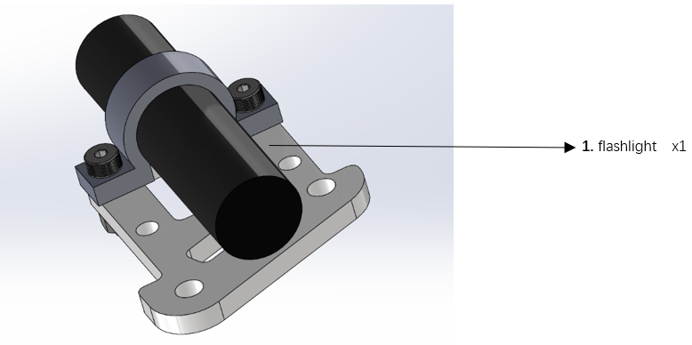

**Step 4:** Align the fixer on top of the flashlight and secure it with shoulder screws and locknuts. Tighten the screws evenly to prevent misalignment or shifting.

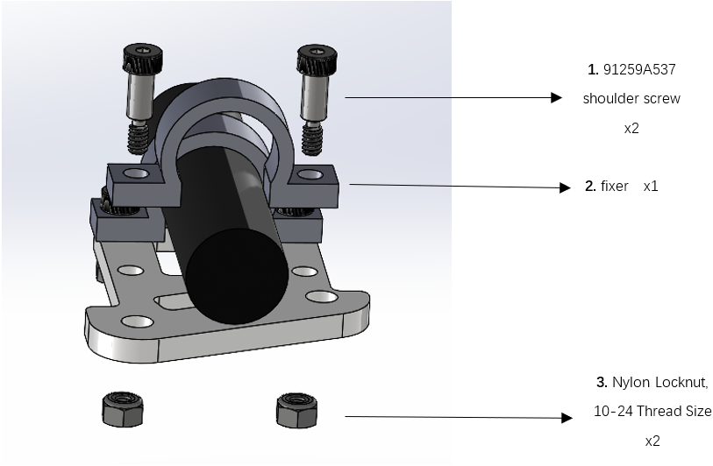

**Step 5:** Add a shoulder screw and a thrust bearing (5906K531) on top of the coupler. Ensure the thrust bearing is properly seated around the screw for smooth rotational movement.

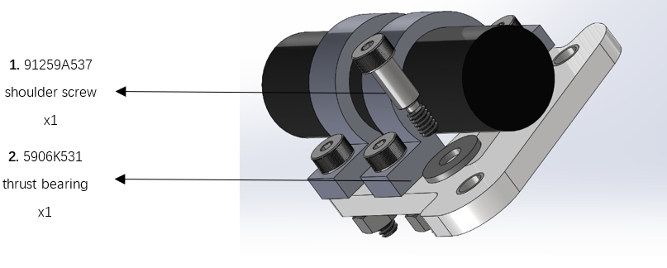

**Step 6:** Install an additional thrust bearing (5906K531) underneath the coupler to provide balanced support. Make sure both the top and bottom thrust bearings are aligned correctly.

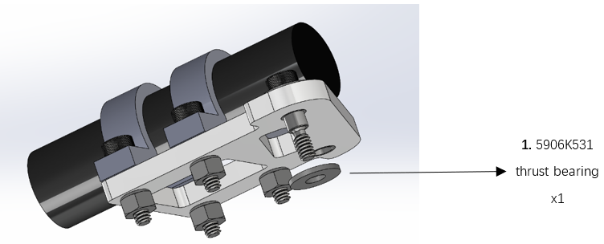

**Step 7:** Place a ball bearing (44xf18) below the lower thrust bearing to enhance rotational efficiency. Confirm the bearing is fitted snugly, allowing free and smooth movement.

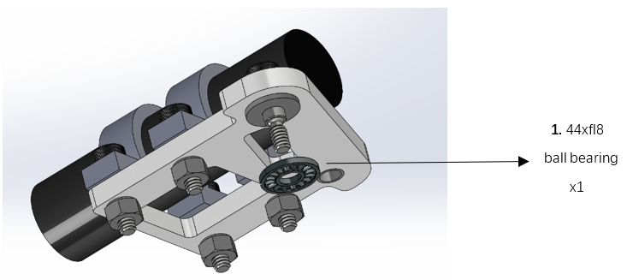

**Step 8:** Add another thrust bearing (5906K531) beneath the ball bearing to stabilize the joint structure. Check for proper alignment to maintain even load distribution.

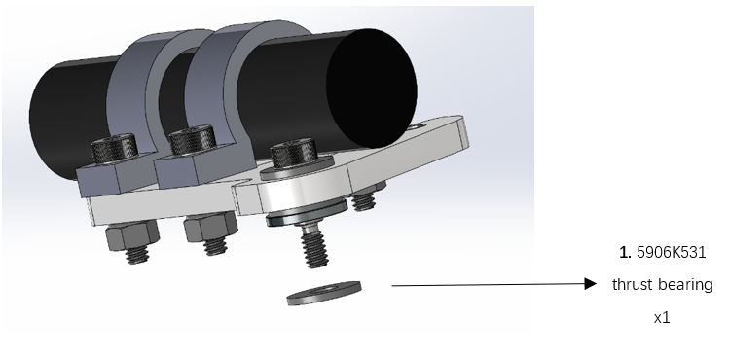

**Step 9:** Connect the input component to the coupler, securing the assembly with the installed bearings. Ensure the connection is tight, with the input rotating smoothly relative to the coupler.

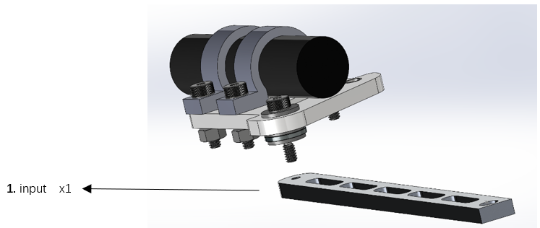

**Step 10:** Repeat Steps 5 through 9 to connect the follower to the coupler using the same joint design. Verify that the follower is securely attached and rotates freely.

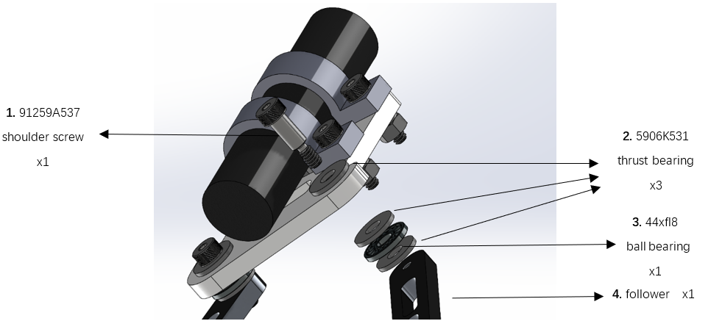

**Step 11:** Attach the bearings needed for input and follower with the same assembly method above..

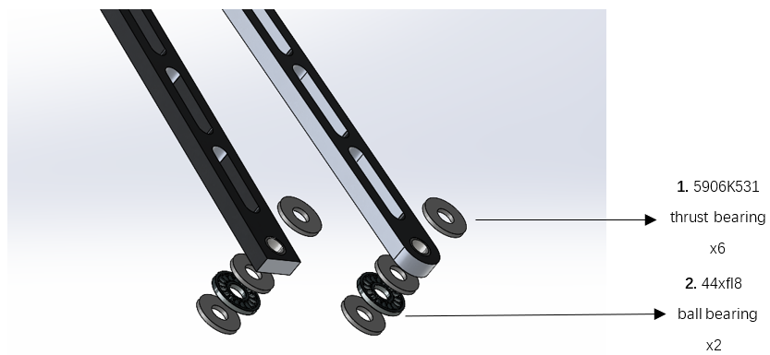

**Step 12:** Secure the follower and input to the baseplate using the same process, ensuring all components are properly aligned and tightly fastened.

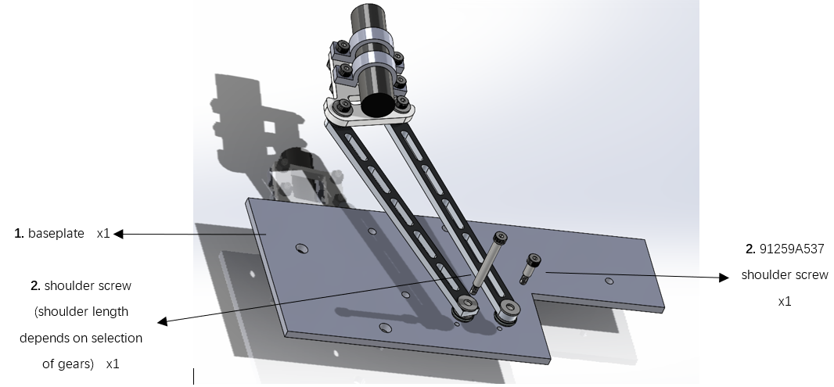

**Step 13:** Attach the gear to the input link

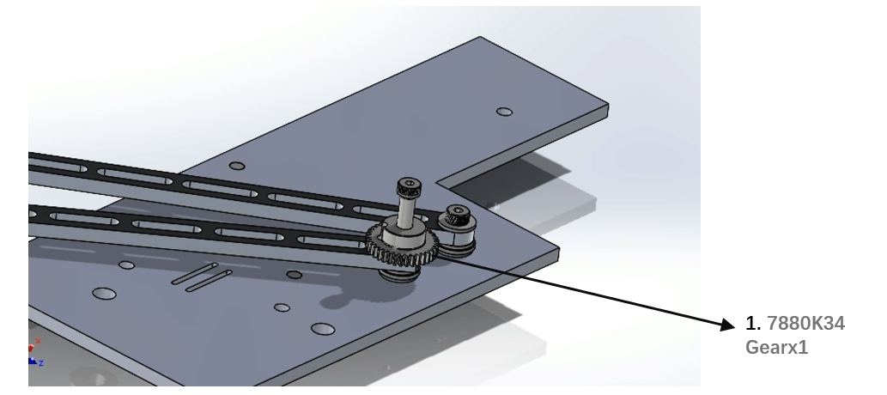

**Step 14:** Insert the spring pin between the gear and the input link, make sure it is aligned with the two holes.

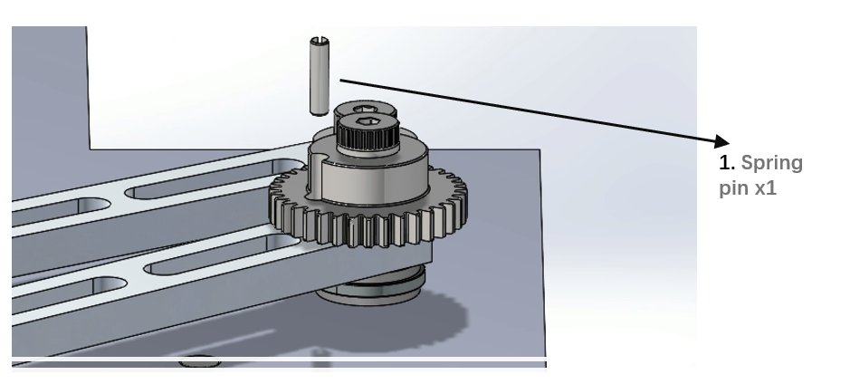

**Step 15:** Put the motor fixer to the baseplate, then insert a dowel pin through the holes on the fixer and the baseplate. Make sure the side of the fixer is parallel to the side of the baseplate.

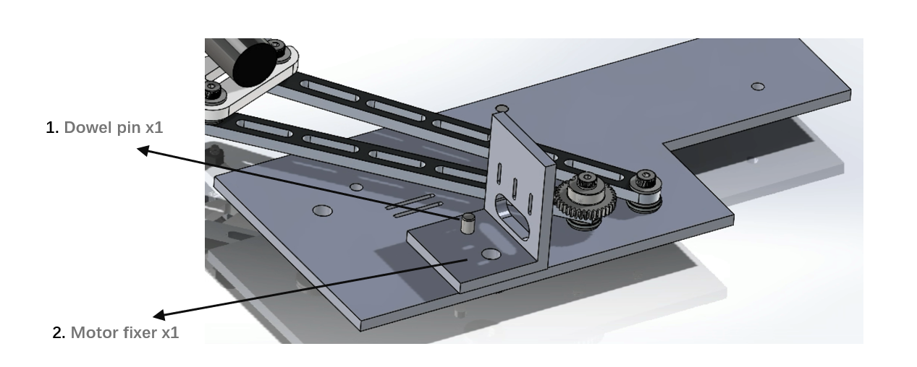

**Step 16:** Insert a socket head cap screw through the holes on both the fixer and baseplate. Before inserting, ensure the two holes are aligned properly.

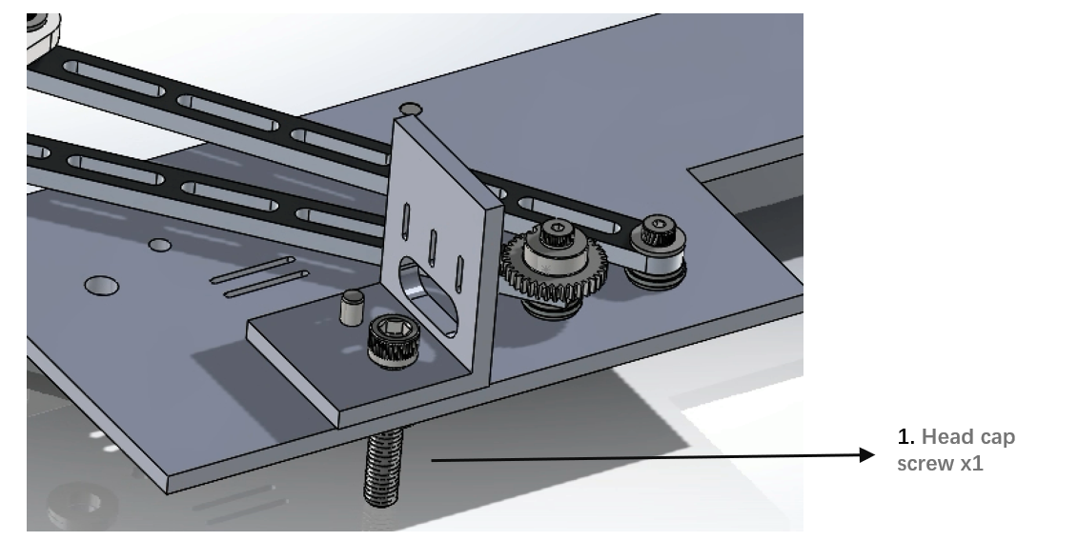

**Step 17:** Firstly, use two M3 screws to roughly assemble the motor bracket. Make the Shaft is on the lower side of the bracket.

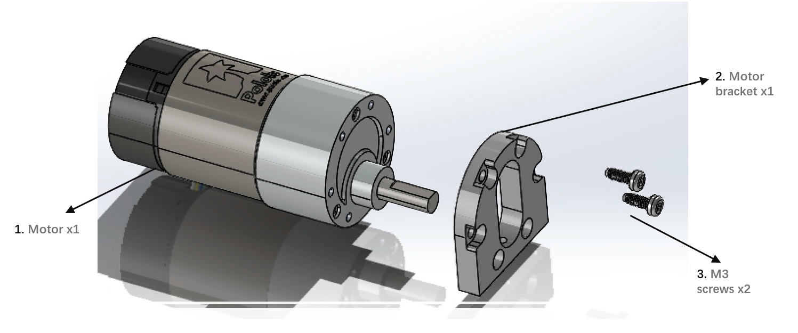

**Step 18:** Use another two M3 screws to firmly fix the motor bracket.

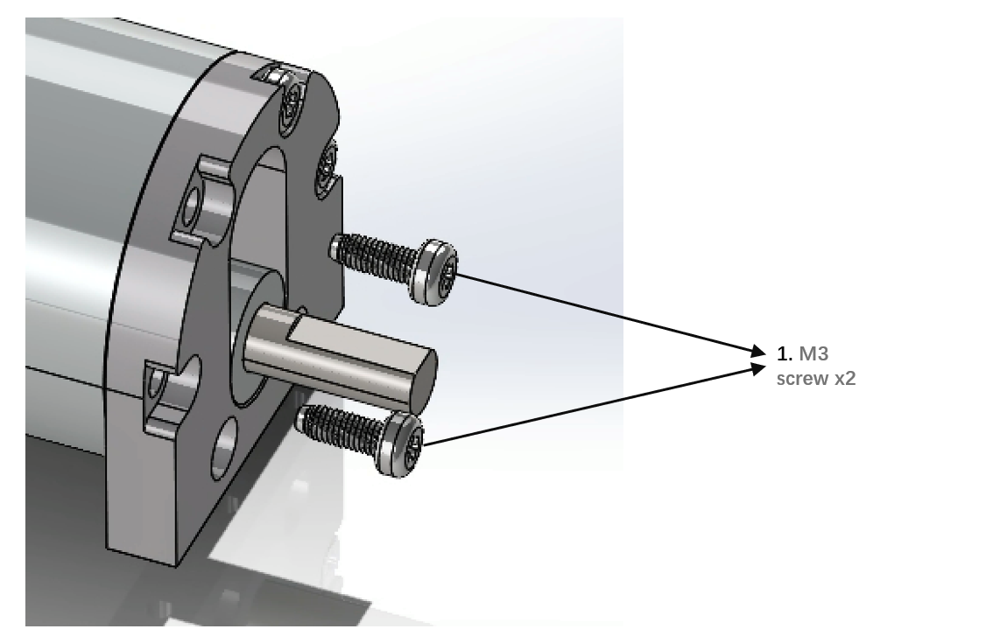

**Step 19:** Use one M3 screw to fix the motor to the fixer.

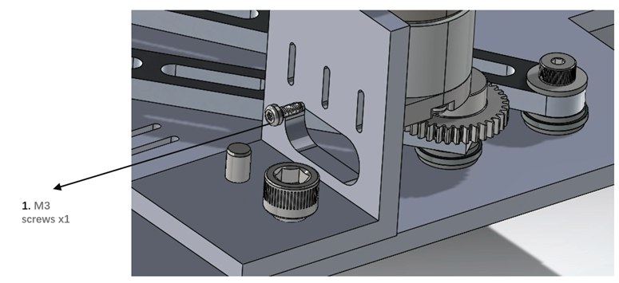

**Step 20:** Then attach another two M3 screws to the motor.

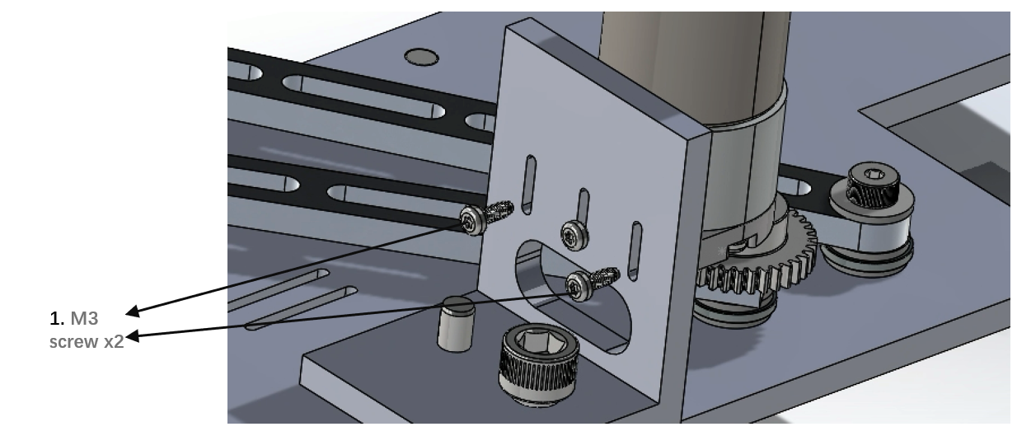

**Step 21:** Install the gear to the motor shaft and adjust its position to a proper position for torque transfer.

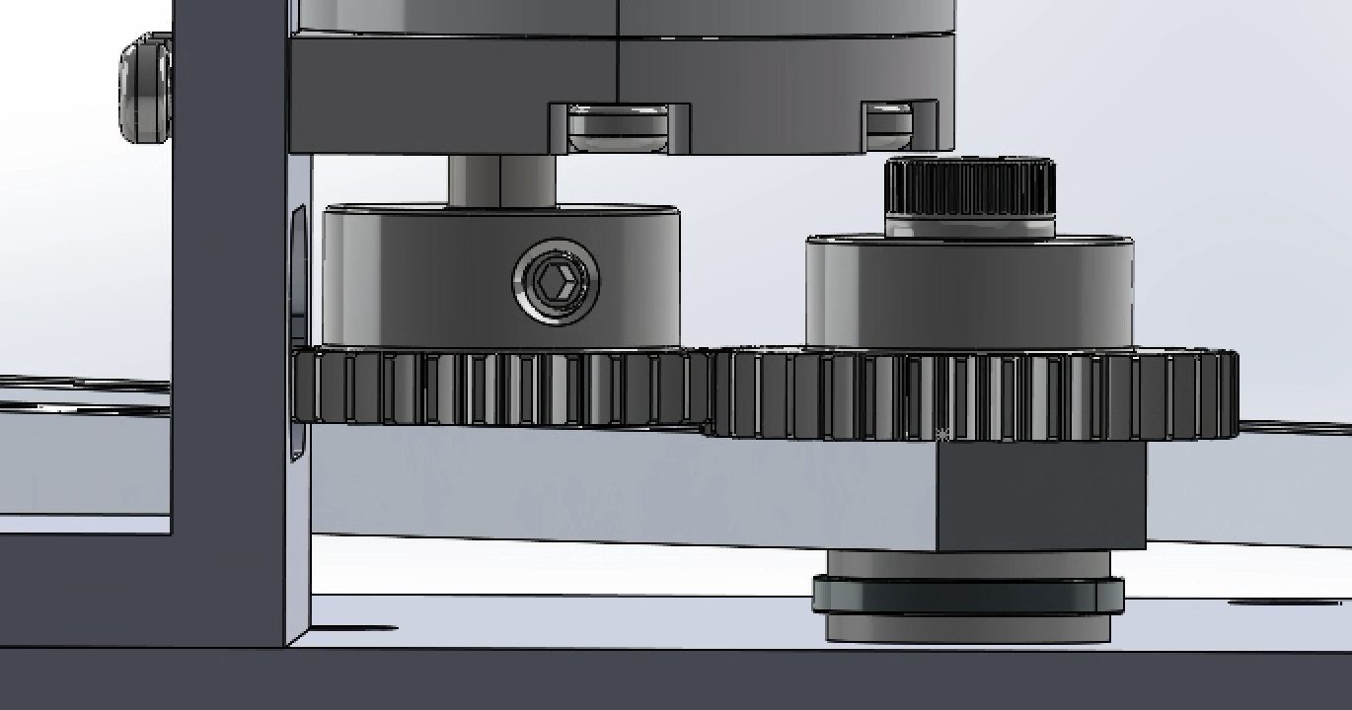

**Step 22:** Attach two dowel pins to the baseplate.

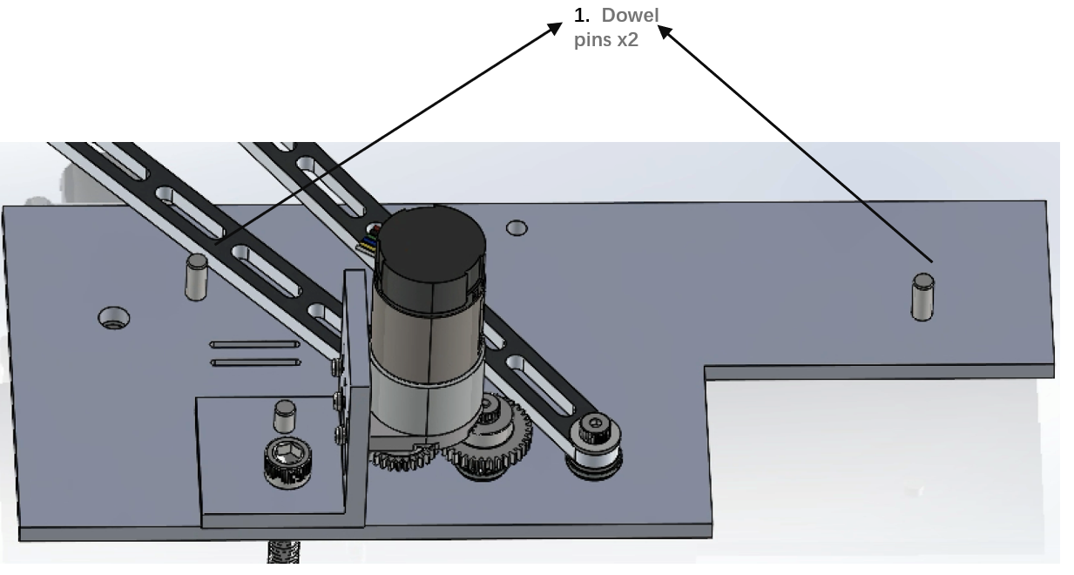

**Step 23:** Put two Nylon spacers to the dowel pins attached at the previous step as a hard stop for our linkage.

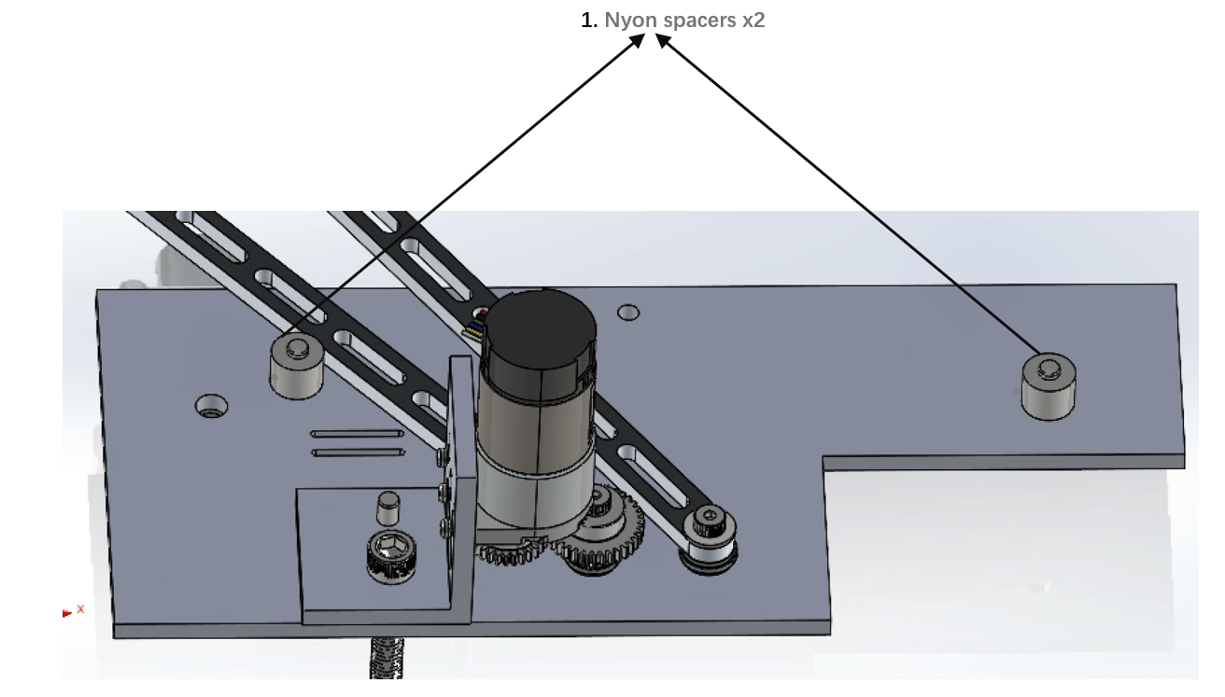

**Appendix B: Bill of Materials for the Final Design**

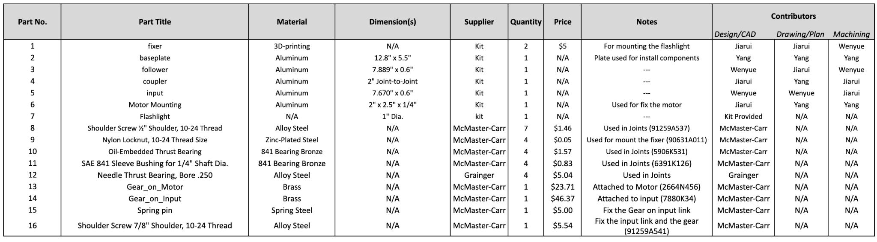

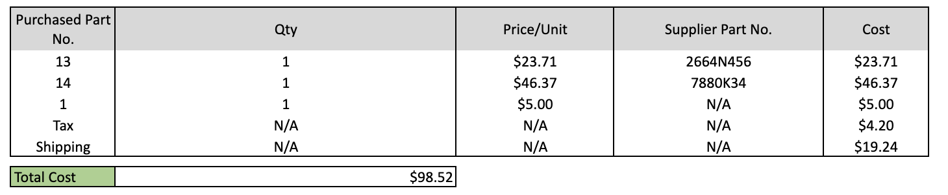

**Appendix C: Approval Packages**

**Follower:**

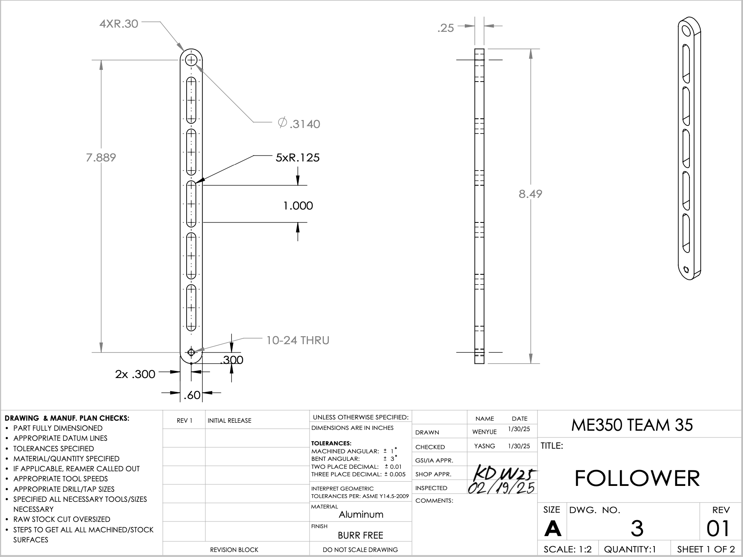

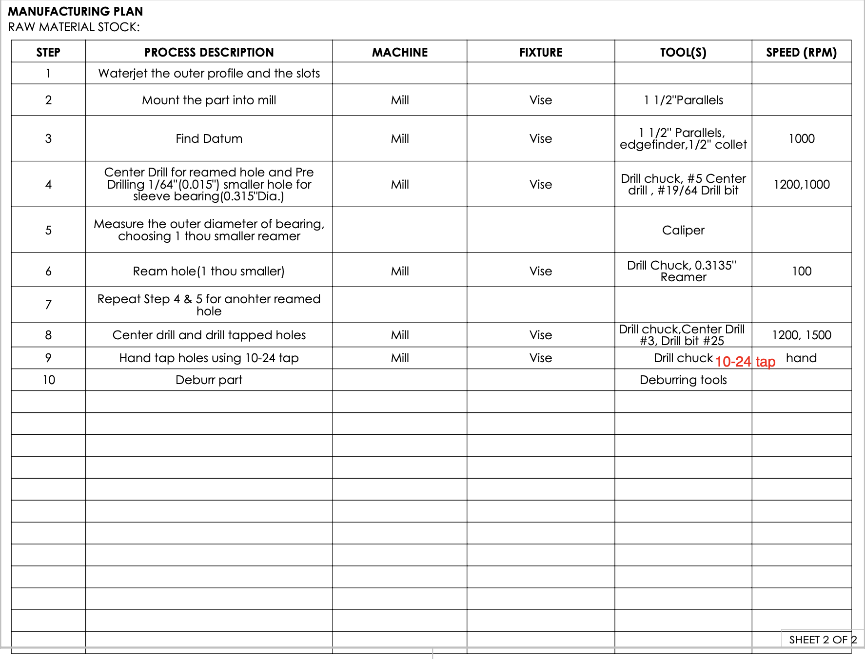

**Baseplate:**

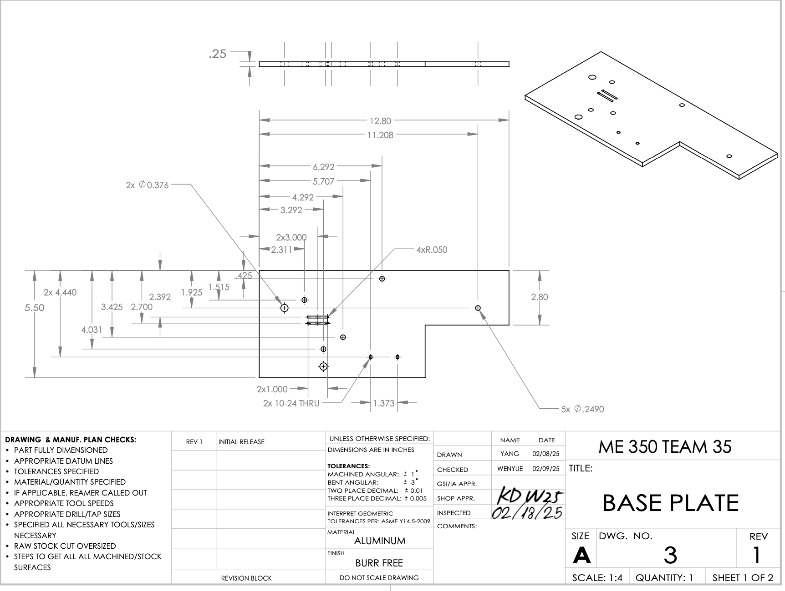

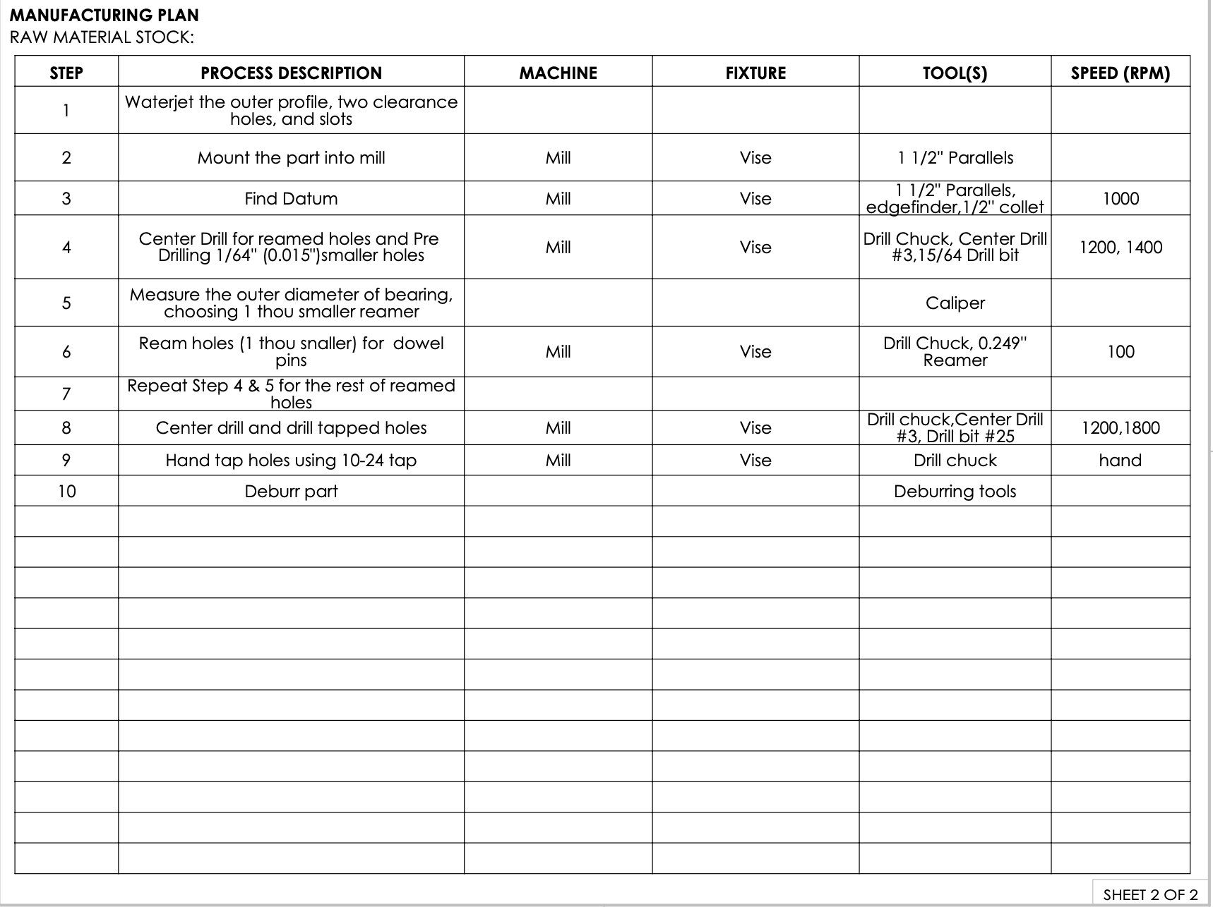

**Motor Fixer:**

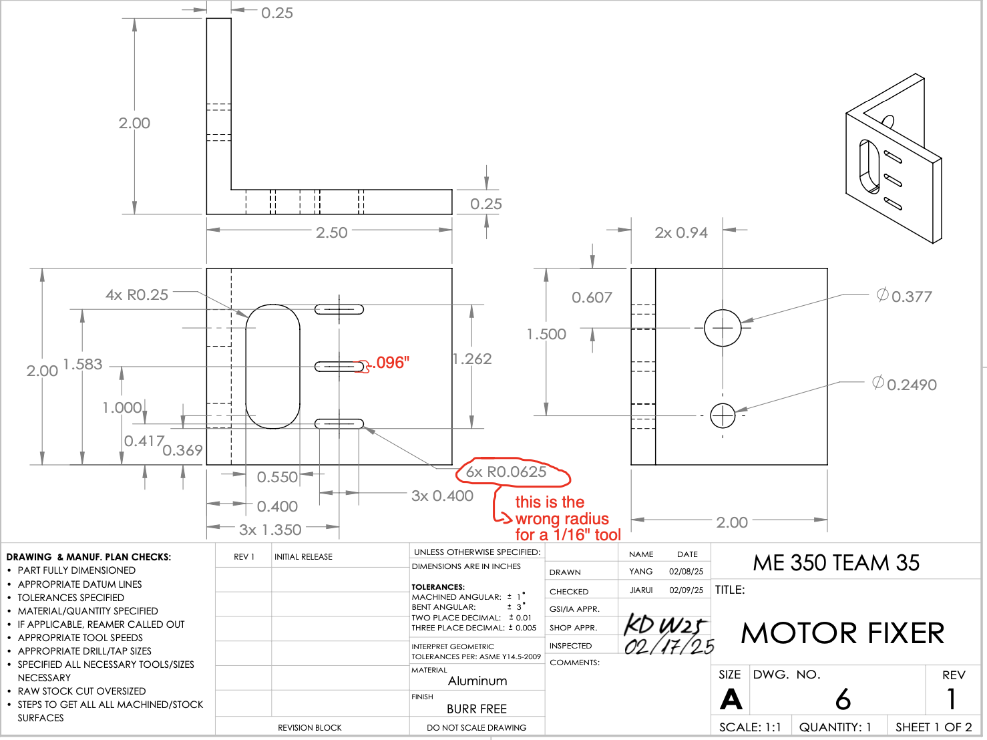

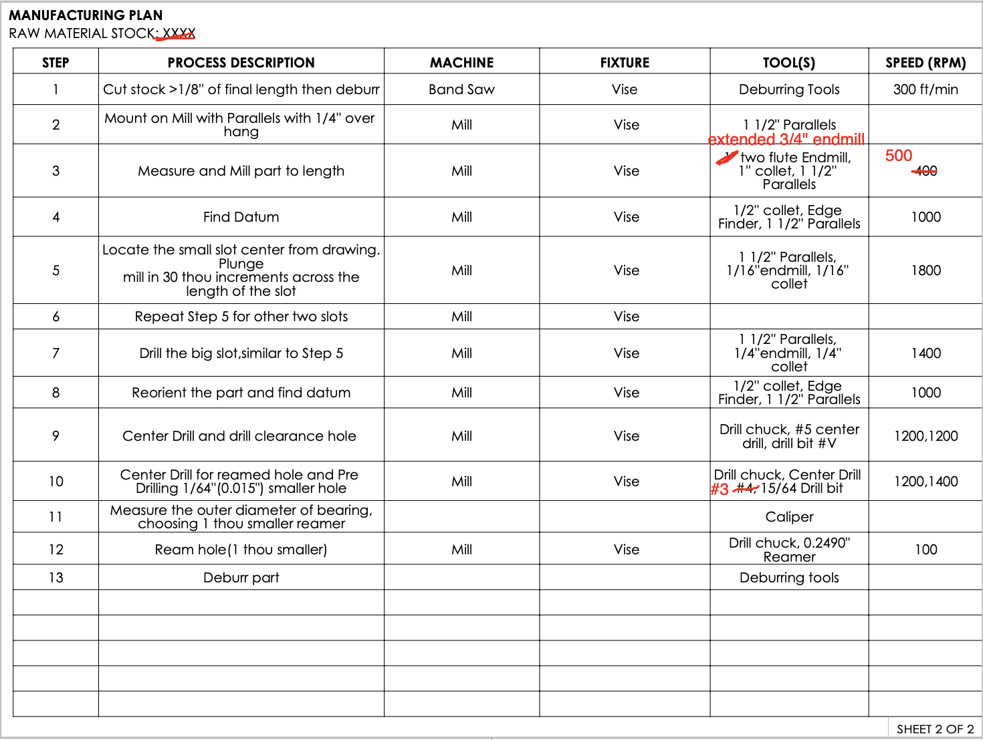

**Input:**

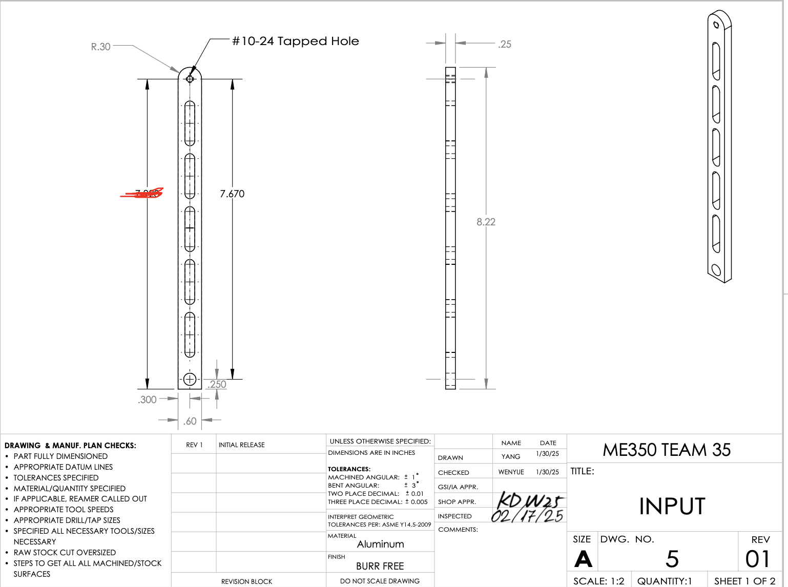

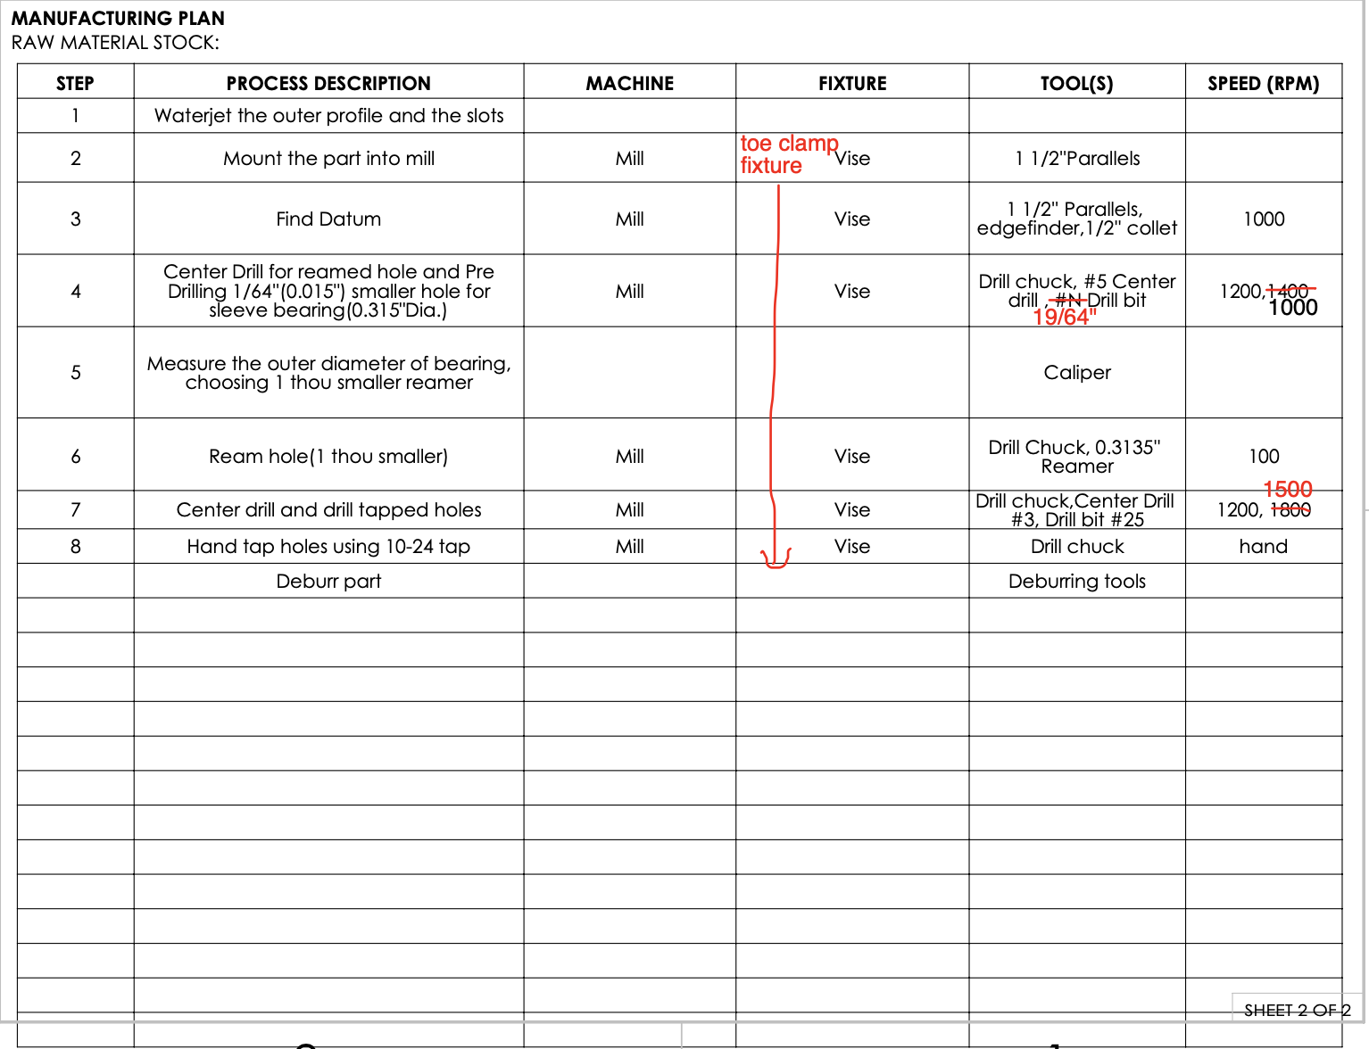

**Coupler:**

